**VISVESVARAYA TECHNOLOGICAL UNIVERSITY**

**Jnana Sangama, Belgaum-590018**



**A Database Management System Mini Project Report**

**on**

**“MyGuest HOTEL MANAGEMENT SYSTEM”**

**Submitted in Partial fulfillment of the Requirements for the V Semester of the Degree of**

**Bachelor of Engineering**

**In**

**Computer Science & Engineering**

**By**

**AYUSH ATUL HATE**

**(1CR15CS036)**

**Under the Guidance of**

**Dr. Jhansi Rani P**

**Professor, Dept. of CSE**



# DEPARTMENT OF Computer SCIENCE AND ENGINEERING

**CMR INSTITUTE OF TECHNOLOGY**

#132, AECS LAYOUT, IT PARK ROAD, KUNDALAHALLI,

BANGALORE-560037

**CMR INSTITUTE OF TECHNOLOGY**

1. #132, AECS LAYOUT, IT PARK ROAD, KUNDALAHALLI,
2. BANGALORE-560037

# DEPARTMENT OF Computer SCIENCE AND ENGINEERING

1. 

**CERTIFICATE**

This is to certify that the Database Management System Project work entitled **“MyGuest Hotel Management System”** has been carried out by **Ayush Atul Hate (1CR15CS036)** bonafide student of CMR Institute of Technology in partial fulfillment for the award of **Bachelor of Engineering** in **Computer Science and Engineering** of the Visvesvaraya Technological University, Belgaum during the year **2017-2018**. It is certified that all corrections/suggestions indicated for Internal Assessment have been incorporated in the Report deposited in the departmental library. This DBMS Project Report has been approved as it satisfies the academic requirements in respect of project work prescribed for the said degree.

**----------------------- ----------------------**

**Signature of Guide Signature of HOD**

**Dr. Jhansi Rani P Mrs. Swathi Y**

**Professor Assoc Professor**

**Dept. of CSE, CMRIT** **Dept. of CSE,Head**

External Viva

Name of the examiners                                                                          Signature with date

1.

2.

**ABSTRACT**

This project aims to build a portal for the guests and front-desk staff at a hotel. The portal is not a commercial hotel room booking page rather, is a system which a person, who has checked into/works at the hotel can use.

At the Guest-end, guests can login to order room service or to book amenities or can view his/her bills at any time.

At the Staff-end, staff members can check-in customers and can check-out guests.

This system has a front-end designed using Hypertext Markup Language, Cascading Stylesheets, JavaScript along with Hypertext Preprocessor and has a back-end database built in MySQL/MariaDB Database Management System using Structured Query Language.

**ACKNOWLEDGEMENT**

The satisfaction and euphoria that accompany a successful completion of any task would be incomplete without the mention of the people who made it possible. So with gratitude I acknowledge all those whose guidance and encouragement served as beacon of light and crowned my efforts with success.

I consider it a privilege to express my sincere gratitude to my internal guide Dr. Jhansi Rani P, Professor, Department of Computer Science & Engineering, CMRIT, Bangalore for her valuable guidance, suggestions and inputs throughout the tenure of this project.

I would like to thank Mr. Kartheek G.C.R, Asst. Professor, Department of Computer Science & Engineering, CMRIT, Bangalore for teaching me the theory concepts of Database Management Systems.

Conclusively, I could like to thank all the faculty members who have always been very cooperative and generous and The Head Of Department Mrs. Swathi Y, Department of Computer Science & Engineering, CMRIT, Bangalore for giving me the opportunity to delve into the field of Database Management Systems and produce a project thereby giving me precious experience in the field.

**TABLE OF CONTENT**

Chapter 1 INTRODUCTION…………………………………....………………………….....1

* 1. Overview………………………………....………..…………………..1
  2. Existing System………………………………………………………..1
  3. Proposed System……………………………...………………………..1

Chapter 2 SYSTEM REQUIREMENTS……………………………………………………....3

2.1 Hardware Requirements…………………………….…………………..3

2.2 Software Requirements………………………………………….........…3

Chapter 3 SYSTEM DESIGN………………………………………………………………....4

3.1 Entity – Relationship Diagram……………………...………………….....4

3.2 Schema Diagram…………………………………….…………………….5

3.3 Use Cases Diagram………………………………………………………..6

Chapter 4 IMPLEMENTATION…………………………………………………………...…7

4.1 Overview……………………..…………………………………………..7

4.2 Back – end Database…………..…………………..……………………..7

4.3 Front – end Code…………………………………....……………………17

Chapter 5 DISCUSSION AND SCREENSHOTS…………………………………………...27

5.1 Home Page………………………………………………………...…….27

4.2 Guest Portal………………………………………....………......………28

4.3 Admin Portal……………………………………….………………........33

Chapter 6 CONCLUSION AND FUTURE SCOPE…….…………………………………...36

6.1 Conclusion……………………………..……………………………......36

6.2 Future Scope…………………………..…………………………….…..36

BIBLIOGRAPHY…………………………………………………………………..………..37

**LIST OF FIGURES AND TABLES**

Fig 3.1 Entity – Relationship Diagram………………………………………………………..4

Fig 3.2 Schema Diagram ……………………………………...………………………………5

Fig 3.3 Use cases Diagram………………………………………………………………...…..6

Fig 5.1 Login page Guest (Default)…………………………… …………………………….27

Fig 5.2 Login page Admin Tab………………………………………………………………27

Fig 5.3 Login Error……………………………………………….…………………………..28

Fig 5.4 Guest Homepage……………………………………………………………………..28

Fig 5.5 Food Ordering Homepage………………………………..…………………………..29

Fig 5.6 Food Order Failure……………………………………….…………………………..30

Fig 5.7 Amenity Booking Tab………………………………………………………………..30

Fig 5.8 Amenity Booking Error…………………………………..………………………….31

Fig 5.9 Guest Invoice Summary…………………………………..………………………….32

Fig 5.10 Admin Homepage(Default)……………………………... ………………………....33

Fig 5.11 Booking a Guest………………………………………………………………….....34

Fig 5.12 Room Booking Failure…………………………………………………………...…34

Fig 5.13 Checking out……………………………………………………………………..…35

Fig 5.14 Check Out Failure………………………………………………..…………………35

Table 4.1 Amenity………………………………………………………………………..……9

Table 4.2 Food…………………………………………………………………………..……10

Table 4.3 Staff………………………………………………………………………………..10

Table 4.4 Room…………………………………………………...……………………….…11

**Chapter 1**

**INTRODUCTION**

* 1. **Overview**

Challenging the systems followed in most hotels, this project aims at building a portal for the guests, staying at the hotel, to order room service, book amenities or to view his/her total bills at any time without having to call hotel staff. The front-desk staff will also use this portal for checking-in and checking-out customers. The portal is designed to be used by guests and staff at the hotel and not for pre-booking of hotel rooms.

* 1. **Existing System**

The existing system to book a room service or amenity is via a phone call to the front desk, or a physical trip to the reception for booking.

* + 1. **Disadvantages of Existing System**

1. Tedious work for the customer.
2. Unavailability of staff.
3. Consumption of time.
4. Customers cannot view his/her bills in real time, they must rely on the hotel staff.
5. Staff members may forget orders or even ignore customer calls especially when there are a lot of people at the hotel.

* 1. **Proposed System**
     1. **Objective**

The proposed system aims at removing the disadvantages of the existing system by making use of a portal which will help the customer to order room service, to schedule amenities and view bills on a system in their room.

* + 1. **Advantages of the proposed system**

1. Customer can order room service and amenities with ease.
2. Staff workload reduces.
3. Customer can view his/her bills whenever they wish.
4. Time is effectively utilized.
5. Guarantee of order placement and amenity booking
6. Easy for customers who may be speech impaired or even shy to perform tasks.
   * 1. **Tools**

NOTEPAD is used for the development of the webpages using HTML/CSS/JS/PHP. MySQL for back-end database and MSWord for Diagrams.

**Chapter 2**

**SYSTEM REQUIREMENTS**

* 1. **Hardware Requirements**

The recommended minimum hardware requirements are a recommended 128MB of RAM for a single-computer system with at least 450MB of free space on a hard disk to store the DBMS, Server Files, Web Browser software.

* 1. **Software Requirements**

The minimum operating system requirements for a windows based system is at least Windows XP running service pack SP2. A web browser, ideally Google Chrome, is used to run the web application. A working installation of XAMPP with MySql 5.6, PHP 7 and Apache Web Server should be configured. Additionally, Apache web server must be set up to run on port 3306.

**Chapter 3**

**SYSTEM DESIGN**

* 1. **Entity-Relationship Diagram**

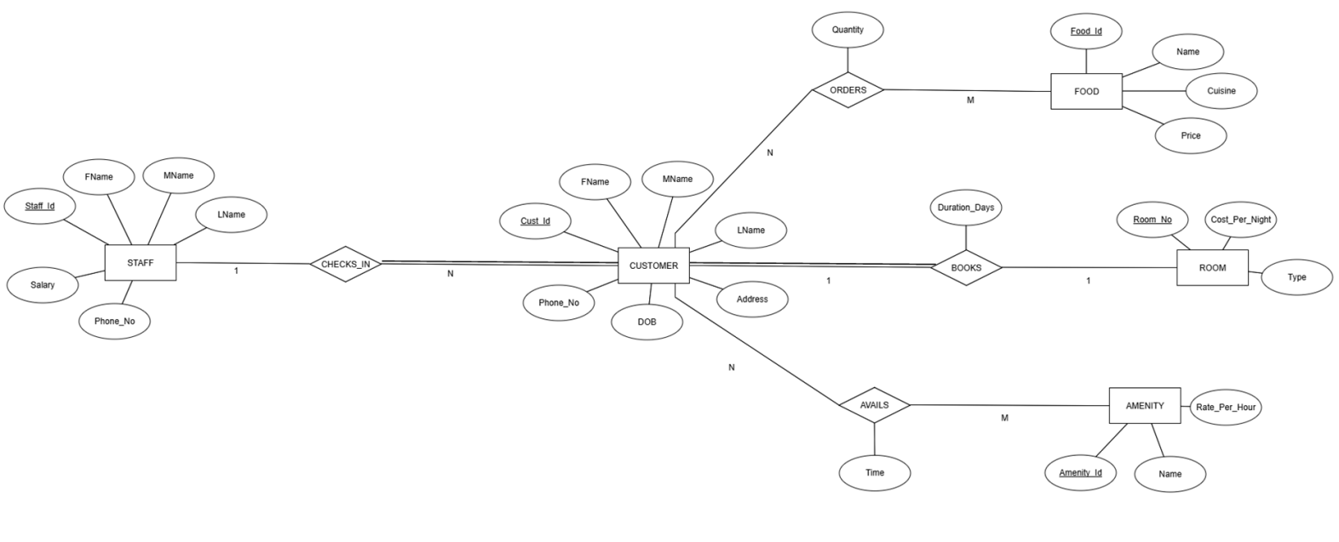 **Fig 3.1 Entity-Relationship Diagram**

ASSUMPTIONS -

* Five entity types are to be assumed - Staff, Customer, Food, Amenity, Room
* The following relationships are assumed -

Staff - Customer : Checks_In

Customer - Food : Orders

Customer - Room : Books

Customer - Amenity : Avails

* It is assumed that one customer can book only one room
* It is assumed that one customer can order many times of food and one food dish can be ordered by any number of customers
* It is assumed that one customer can avail many times of amenities and one amenity is available to any number of customers
* It is assumed that one staff member can check in any number of customers.
  1. **Schema Diagram**

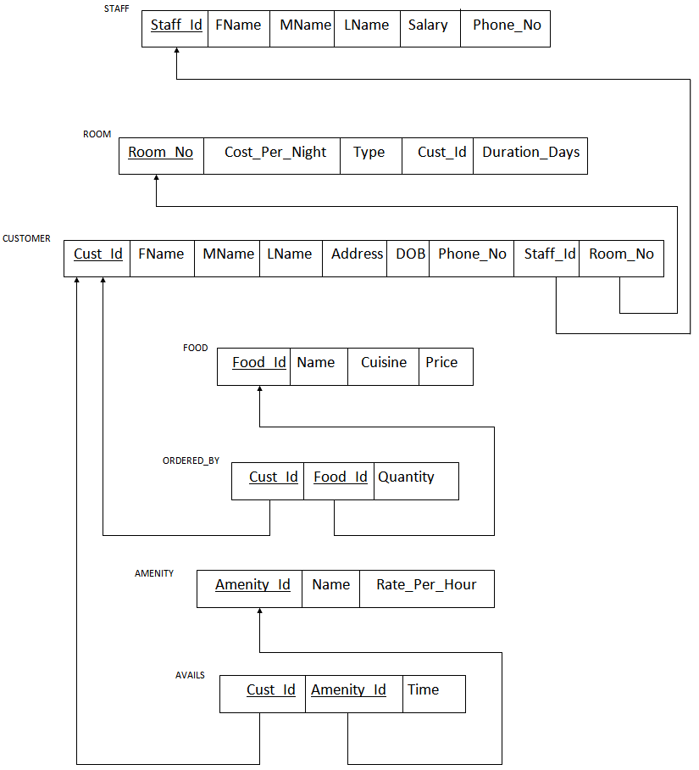

**Fig 3.2 Schema Diagram**

Using the Entity-relation mapping rules, the Schema Diagram in Fig 3.2 is obtained, showing all the data relations and relationship relations for the ER Diagram in Fig 3.1. Overall, we obtain a set of 7 relations out of which 5 relations are data relations and 2 are relationship relations describing their respective 'm:n' order relations.

* 1. **Use-Case Diagram**

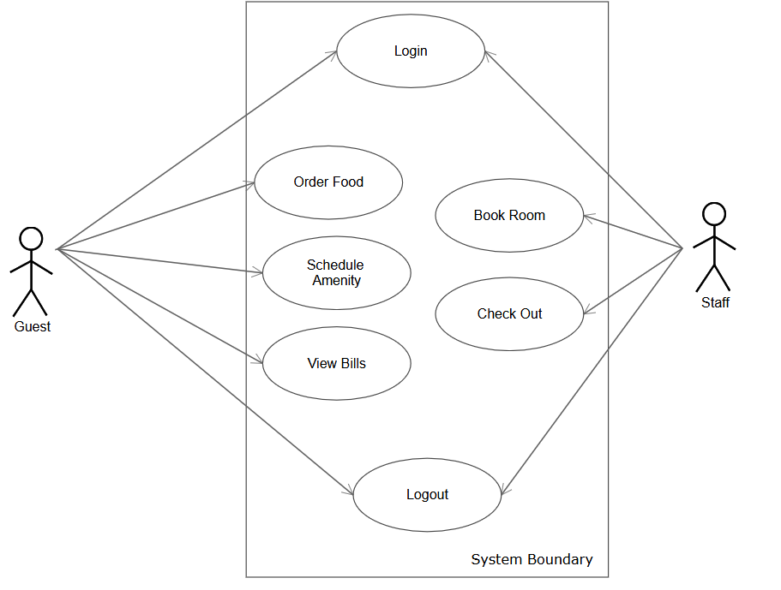

**Fig 3.3 Use Case Diagram**

**Chapter 4**

**IMPLEMENTATION**

* 1. **Overview**

The web application is written using a multitude of commonly used front-end and back-end languages. The webpage, its formatting and styling for all static parts was done in Hyper Text Markup Language (HTML) with styling done with 'in <style>' Cascading Style Sheets (CSS). The database parts were done using MySql/Maria DB DBMS using Structured Query Language (SQL). The dynamic interleaving of the front end static webpage and the database was accomplished with the help of Hypertext Preprocessor (PHP) language.

* 1. **Back-End Database**

The HotelDB Database was created in MySql/MariaDB using SQL. Following are the create, insert and alter statements to initialize the database.

* + 1. **Creation of Tables**

1. CREATE TABLE STAFF(

Staff_Id int PRIMARY KEY,

FName varchar(20),

MName varchar(20),

LName varchar(20),

Phone_No varchar(10),

);

1. ALTER TABLE STAFF

ADD FOREIGN KEY (Dept_Id) REFERENCES DEPARTMENT(Dept_Id);

1. CREATE TABLE CUSTOMER (

Cust_Id int PRIMARY KEY,

FName varchar(20),

MName varchar(20),

LName varchar(20),

DOB DATE,

Age int,

Address TEXT,

Phone_No varchar(10),

Staff_Id int,

FOREIGN KEY(Staff_Id) REFERENCES STAFF(Staff_Id) ON DELETE SET NULL);

1. CREATE TABLE ROOM (

Room_No varchar(10) PRIMARY KEY,

Cost_Per_Night DECIMAL(13,2),

Type varchar(20),

Cust_Id int,

FOREIGN KEY(Cust_Id) REFERENCES CUSTOMER(Cust_Id) ON DELETE SET NULL,

Duration_Days int);

1. CREATE TABLE AMENITY (

Amenity_Id int PRIMARY KEY,

Name varchar(20),

Rate_Per_Hour DECIMAL(13,2));

1. CREATE TABLE FOOD (

Food_Id int PRIMARY KEY,

Name varchar(20),

Cuisine varchar(20),

Price DECIMAL(13,2));

1. CREATE TABLE ORDERED_BY (

Cust_Id int,

Food_Id int

Quantity int DEFAULT 1);

1. ALTER TABLE ORDERED_BY

ADD PRIMARY KEY(Cust_Id,Food_Id);

1. ALTER TABLE ORDERED_BY

ADD FOREIGN KEY(Cust_Id) REFERENCES CUSTOMER(Cust_Id) ON DELETE CASCADE;

1. ALTER TABLE ORDERED_BY

ADD FOREIGN KEY(Food_Id) REFERENCES FOOD(Food_Id);

1. CREATE TABLE AVAILS (

Cust_Id int,

Amenity_Id int

Time int);

1. ALTER TABLE AVAILS

ADD PRIMARY KEY(Cust_Id,Amenity_Id);

1. ALTER TABLE AVAILS

ADD FOREIGN KEY(Amenity_Id) REFERENCES AMENITY(Amenity_Id) ON DELETE CASCADE;

1. ALTER TABLE AVAILS

ADD FOREIGN KEY(Cust_Id) REFERENCES CUSTOMER(Cust_Id) ON DELETE CASCADE;

* + 1. **Insertion of Data**

1. INSERT INTO AMENITY VALUES

(3001,"Room Service", 0.00),

(3002,"Swimming Pool", 20.00),

(3003,"Health Club", 50.00),(3004,"Spa",100.00),

(3005,"Mini-Bar",200.00),

(3006,"Laundry",100.00),

(3007,"Casino",500.00),

(3009,"Games Room",100.00),

(3010,"Sports",100.00);

|  |  |  |
| --- | --- | --- |
| Amenity_Id | Name | Rate_Per_Hour |
| 3001 | Room Service | 0.00 |
| 3002 | Swimming Pool | 20.00 |
| 3003 | Health Club | 50.00 |
| 3004 | Spa | 100.00 |
| 3005 | Mini-Bar | 200.00 |
| 3006 | Laundry | 100.00 |
| 3007 | Casino | 500.00 |
| 3009 | Games Room | 100.00 |
| 3010 | Sports | 100.00 |

**Table 4.1 Amenity**

1. INSERT INTO FOOD VALUES

(4001,"Vegetarian Soup", "Asian",15.00),

(4002,"Non-Vegetarian Soup","Asian",20.00),

(4003,"Paneer Tikka", "Indian",30.00),

(4004,"Chicken Nuggets", "American", 30.00),

(4005,"Garlic Bread","Italian",25.00),

(4006,"Fried Rice", "Chinese", 30.00),

(4007,"Pizza Margharita","Italian",50.00),

(4008,"Mutton Handi","Indian",35.00),

(4009,"Red Curry/Green Curry Chicken","Thai",40.00),

(4010,"Spinach with Chilli and Lemon Crumbs","Mediterranean",30.00),

(4011,"Fondue","Swiss",20.00),

(4012,"Assorted Naan/Roti","Indian",50.00),

(4013,"Rasgulla","Indian",20.00),

(4014,"Ice-Cream-Sundae","American",20.00),

(4015,"Gelato","Italian",15.00),(4016,"Mineral Water","",5.00),

(4017,"Soft-Drinks","",10.00);

|  |  |  |  |
| --- | --- | --- | --- |
| Food_Id | Name | Cuisine | Price |
| 4001 | Vegetarian Soup | Asian | 15.00 |
| 4002 | Non-Vegetarian Soup | Asian | 20.00 |
| 4003 | Paneer Tikka | Indian | 30.00 |
| 4004 | Chicken Nuggets | American | 30.00 |
| 4005 | Garlic Bread | Italian | 25.00 |
| 4006 | Fried Rice | Chinese | 30.00 |
| 4007 | Pizza Margharita | Italian | 50.00 |
| 4008 | Mutton Handi | Indian | 35.00 |
| 4009 | Red Curry/Green Curry Chicken | Thai | 40.00 |
| 4010 | Spinach with Chilli and Lemon Crumbs | Mediterranean | 30.00 |
| 4011 | Fondue | Swiss | 20.00 |
| 4012 | Assorted Naan/Roti | Indian | 50.00 |
| 4013 | Rasgulla | Indian | 20.00 |
| 4014 | Ice-Cream-Sundae | American | 20.00 |
| 4015 | Gelato | Italian | 15.00 |
| 4016 | Mineral Water |  | 5.00 |
| 4017 | Soft-Drinks |  | 10.00 |

**Table 4.2 Food**

1. INSERT INTO STAFF VALUES

(101001,"Ayush","Atul","Hate","9594356709",1500000.00),

(101002,"Ishita","","Dongre","9972224900",1000000.00);

|  |  |  |  |  |  |
| --- | --- | --- | --- | --- | --- |
| Staff_Id | FName | MName | LName | Phone_No | Salary |
| 101001 | Ayush | Atul | Hate | 9594356709 | 1500000 |
| 101002 | Ishita | NULL | Dongre | 9972224900 | 1000000 |

**Table 4.3 Staff**

1. INSERT INTO ROOM VALUES

(1,2000,"Basic","",""),

(2,4000,"Deluxe","",""),

(3,6000,"Super Deluxe","",""),

(4,8000,"Imperial","",""),

(5,10000,"Royal","",""),

(6,15000,"Presidential","","");

|  |  |  |  |  |
| --- | --- | --- | --- | --- |
| Room_No | Cost_Per_Night | Type | Cust_Id | Duration_Days |
| 1 | 2000 | Basic | NULL | NULL |
| 2 | 4000 | Deluxe | NULL | NULL |
| 3 | 6000 | Super Deluxe | NULL | NULL |
| 4 | 8000 | Imperial | NULL | NULL |
| 5 | 10000 | Royal | NULL | NULL |
| 6 | 15000 | Presidential | NULL | NULL |

**Table 4.4 Room**

* + 1. **Queries Used**

1. Login Queries:
   1. Guest:

SELECT Cust_Id, Phone_No

FROM CUSTOMER

WHERE Cust_Id= '$Cust_Id' AND Phone_No = '$Phone_No

* 1. Admin:

SELECT Staff_Id, Phone_No

FROM STAFF

WHERE Staff_Id= '$Staff_Id' AND Phone_No = '$Phone_No';

1. Login Name Retrieval Queries:
   1. Guest:

SELECT FName

FROM CUSTOMER

WHERE Cust_Id='$Cust_id'

* 1. Admin:

SELECT FName

FROM STAFF

WHERE Staff_Id='$Staff_id'';

1. Guest Page Functions:
   1. Order Food:

REPLACE INTO ORDERED_BY VALUES ('$Cust_Id','$Food_Id','$Quantity')

* 1. Schedule Amenity:

REPLACE INTO AVAILS VALUES('$Cust_Id','$Amenity_Id','$Time')

* 1. Calling Bill Stored Procedures:

Room Bill:

CALL RoomBills('$Cust_id',@RoomCost)

Food Bill:

CALL FoodBills('$Cust_id',@FoodCost)

Amenity Bill:

CALL AmenityBills('$Cust_id',@AmenityCost)

* 1. Setting Cost Totals for Each category:

Setting Cost Total:

SELECT COST

FROM TotalBillViewBase

WHERE CUSTOMER_ID = '$Cust_id'

Total Bill:

CALL TotalBill('$Cust_id',@TotalCost)

1. Admin Page Functions:
   1. Booking a Room:
      1. INSERT INTO CUSTOMER VALUES

('$Cust_Id','$FName','$MName','$LName',

'$DOB','$Address','$Phone_No','$Staff_Id','$Room_No');

* + 1. UPDATE ROOM

SET Cust_Id = '$Cust_Id', Duration_Days = '$Duration_Days' WHERE Room_No = '$Room_No'

* 1. Checking Out:
     1. DELETE FROM CUSTOMER

WHERE Cust_Id = '$Cust_Id';

* + 1. UPDATE ROOM

SET Duration_Days = NULL

WHERE Room_No = '$Room_No';

* + 1. **Views and Stored Procedures**
    2. VIEW FOR ROOM BILL

CREATE VIEW RoomBillView AS

(SELECT R.Cust_Id AS 'CUSTOMER_ID', R.Type AS 'TYPE', R.Cost_Per_Night AS 'COST', R.Duration_Days AS 'DAYS', (R.Cost_Per_Night*R.Duration_Days) AS 'TOTAL'

FROM ROOM AS R

WHERE R.Cust_Id IS NOT NULL

);

* + 1. VIEW FOR FOOD BILL

CREATE VIEW FoodBillView AS

(SELECT O.Cust_Id AS 'CUSTOMER_ID', F.Food_Id AS 'FOOD_ID', F.Name AS 'NAME', F.Price AS 'COST', O.Quantity AS 'QUANTITY_ORDERED', (F.Price*O.Quantity) AS 'TOTAL'

FROM FOOD AS F NATURAL JOIN ORDERED_BY AS O

);

* + 1. VIEW FOR AMENITY BILL

CREATE VIEW AmenityBillView AS

(SELECT Av.Cust_Id AS 'CUSTOMER_ID', A.Amenity_Id AS 'AMENITY_ID', A.Name AS 'NAME', A.Rate_Per_Hour AS 'RATE', Av.Time AS 'DURATION', (A.Rate_Per_Hour*Av.Time) AS 'TOTAL'

FROM AMENITY AS A NATURAL JOIN AVAILS AS Av);

* + 1. VIEWS FOR TOTAL BILL
* CREATE VIEW TotalBillViewBase AS

(SELECT R.CUSTOMER_ID, SUM(R.TOTAL) AS COST

FROM RoomBillView AS R

GROUP BY R.CUSTOMER_ID)

UNION

(SELECT F.CUSTOMER_ID, SUM(F.TOTAL)

FROM FoodBillView AS F

GROUP BY F.CUSTOMER_ID)

UNION

(SELECT A.CUSTOMER_ID, SUM(A.TOTAL)

FROM AmenityBillView AS A

GROUP BY A.CUSTOMER_ID);

* CREATE VIEW TotalBillView AS

(SELECT T.CUSTOMER_ID AS 'CUSTOMER_ID', SUM(T.COST) AS'TOTAL'

FROM TotalBillViewBase AS T

GROUP BY T.CUSTOMER_ID);

* + 1. PROCEDURE FOR ROOM BILL

DELIMITER $$$

CREATE PROCEDURE RoomBills (IN Custid INT, OUT RoomCost DECIMAL(13,2))

BEGIN

SELECT TYPE,COST,DAYS,TOTAL

FROM RoomBillView

WHERE CUSTOMER_ID = Custid;

SELECT TOTAL INTO RoomCost

FROM RoomBillView

WHERE CUSTOMER_ID = Custid;

END $$$

DELIMITER ;

* + 1. PROCEDURE FOR FOOD BILL

DELIMITER $$$

CREATE PROCEDURE FoodBills (IN Custid INT, OUT FoodCost DECIMAL(13,2))

BEGIN

SELECT NAME,COST,QUANTITY_ORDERED,TOTAL

FROM FoodBillView

WHERE CUSTOMER_ID = Custid;

SELECT SUM(TOTAL) INTO FoodCost

FROM RoomBillView

WHERE CUSTOMER_ID = Custid;

END $$$

DELIMITER ;

* + 1. PROCEDURE FOR AMENITY BILL

DELIMITER $$$

CREATE PROCEDURE AmenityBills (IN Custid INT, OUT AmenityCost DECIMAL(13,2))

BEGIN

SELECT NAME,RATE,DURATION,TOTAL

FROM AmenityBillView

WHERE CUSTOMER_ID = Custid;

SELECT SUM(TOTAL) INTO AmenityCost

FROM AmenityBillView

WHERE CUSTOMER_ID = Custid;

END $$$

DELIMITER ;

* + 1. PROCEDURE FOR TOTAL BILL

DELIMITER $$$

CREATE PROCEDURE TotalBill (IN Custid INT, OUT TotalCost DECIMAL(13,2))

BEGIN

SELECT TOTAL

FROM TotalBillView

WHERE CUSTOMER_ID = Custid;

END $$$

DELIMITER ;

* + 1. **Triggers**
    2. FOOD ORDER

DELIMITER $$

CREATE TRIGGER FoodOrder BEFORE INSERT ON ORDERED_BY

FOR EACH ROW BEGIN

DECLARE rowCount INT;

DECLARE newQty INT;

SET rowCount = (SELECT COUNT(*) FROM ORDERED_BY WHERE Cust_Id = NEW.Cust_Id AND Food_Id = NEW.Food_Id);

SET newQty = (SELECT Quantity FROM ORDERED_BY WHERE Cust_Id = NEW.Cust_Id AND Food_Id = NEW.Food_Id);

IF(rowCount>0) THEN

SET NEW.Quantity = newQty + NEW.Quantity;

END IF;

END$$

DELIMITER ;

* + 1. AMENITY BOOK

DELIMITER $$

CREATE TRIGGER AmenityBook BEFORE INSERT ON AVAILS

FOR EACH ROW BEGIN

DECLARE rowCount INT;

DECLARE newTime INT;

SET rowCount = (SELECT COUNT(*) FROM AVAILS WHERE Cust_Id = NEW.Cust_Id AND Amenity_Id = NEW.Amenity_Id);

SET newTime = (SELECT Time FROM AVAILS WHERE Cust_Id = NEW.Cust_Id AND Amenity_Id = NEW.Amenity_Id);

IF(rowCount>0) THEN

SET NEW.Time = newTime + NEW.Time;

END IF;

END$$

DELIMITER ;

* 1. **Front-End Code**
     1. **HTML**
     2. Tabbed Home Page:

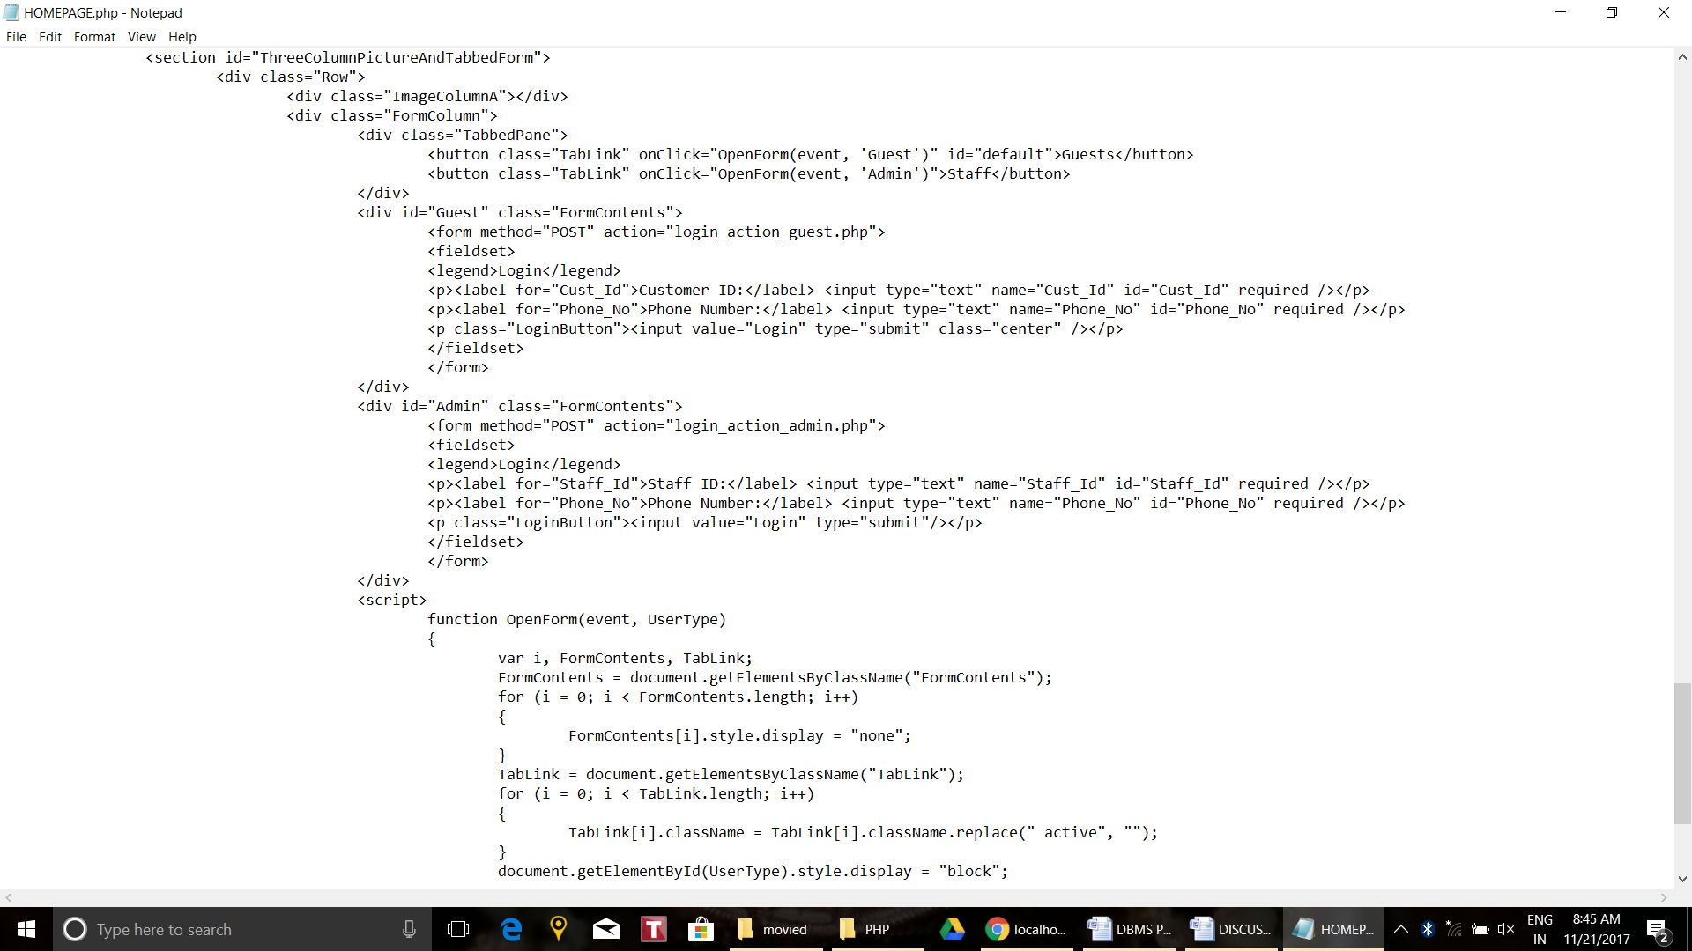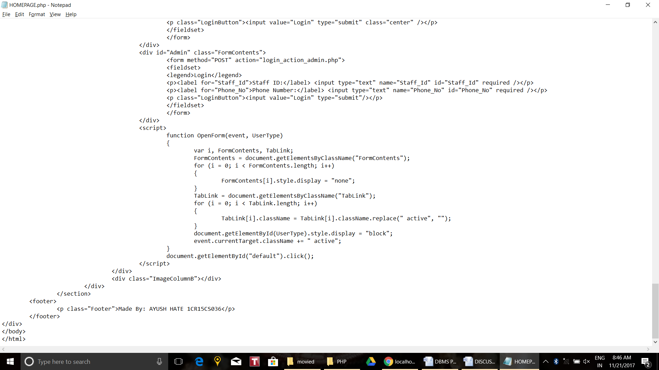

* + 1. Admin Page:

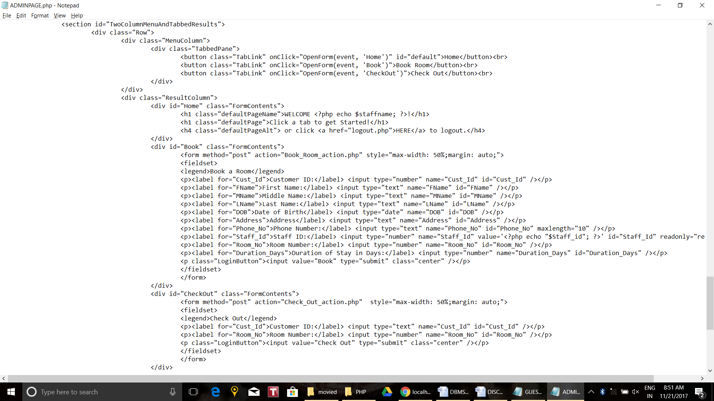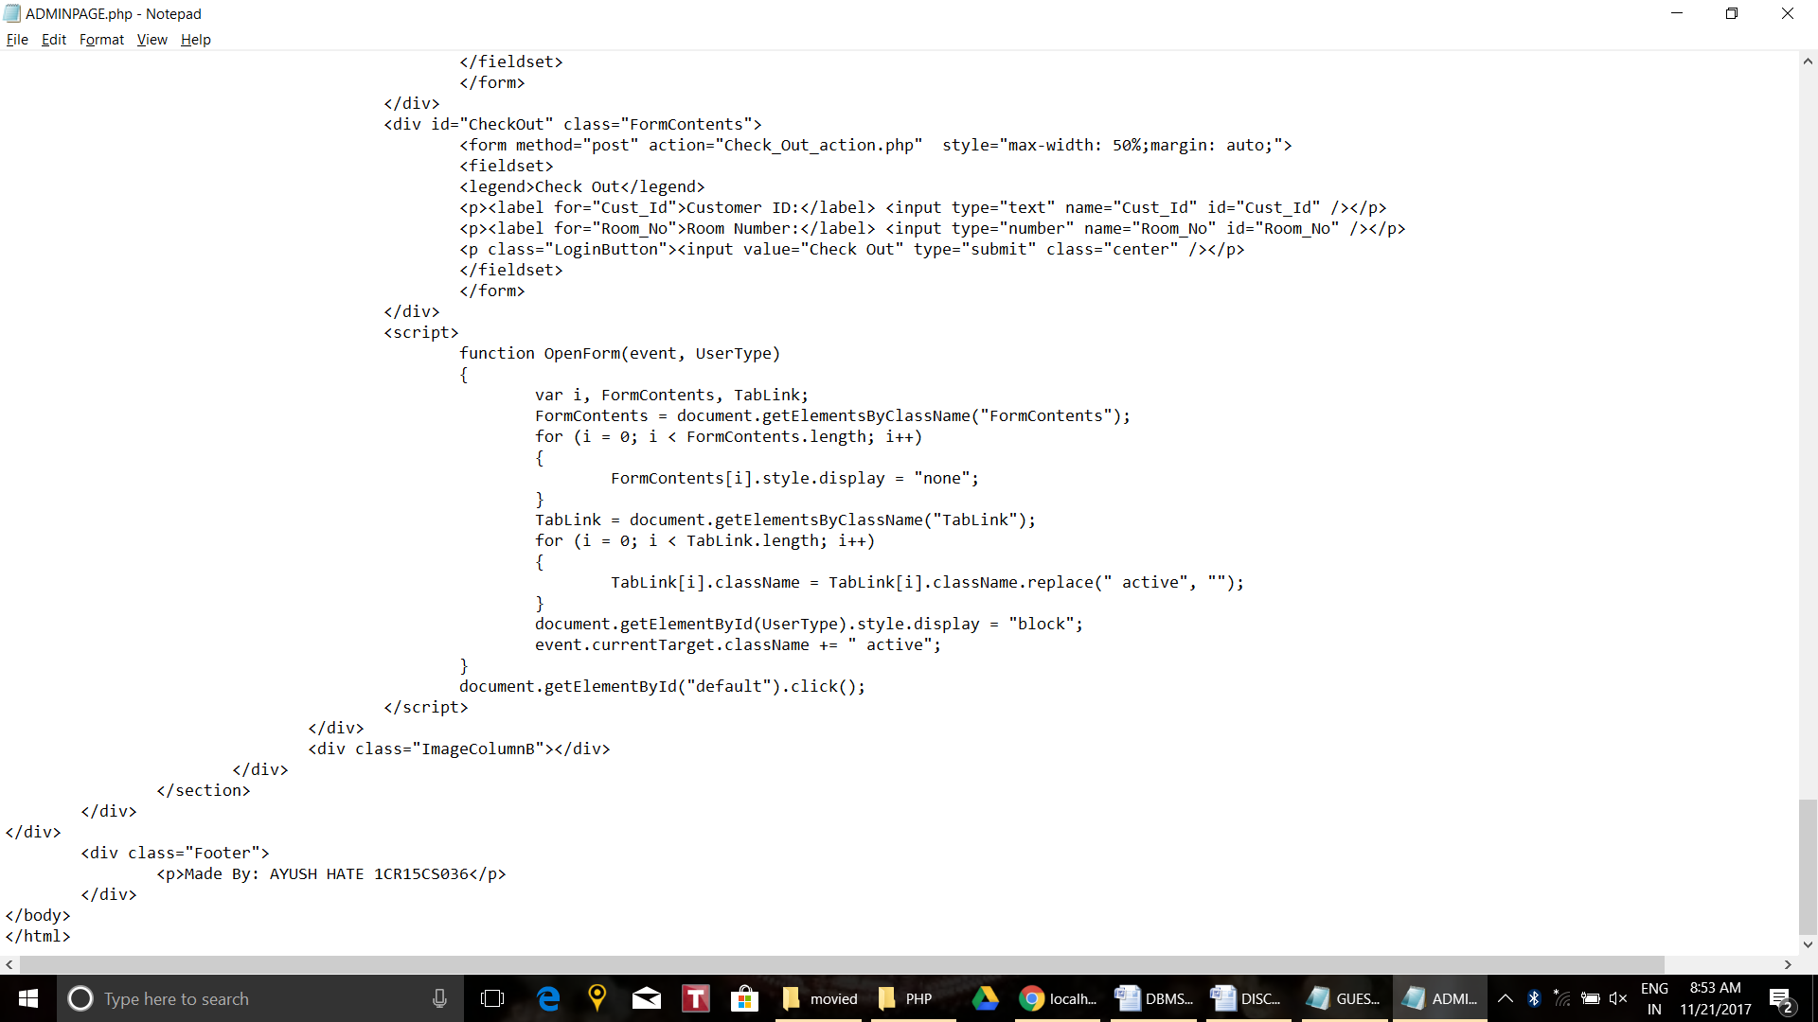

* + 1. Guest Page:

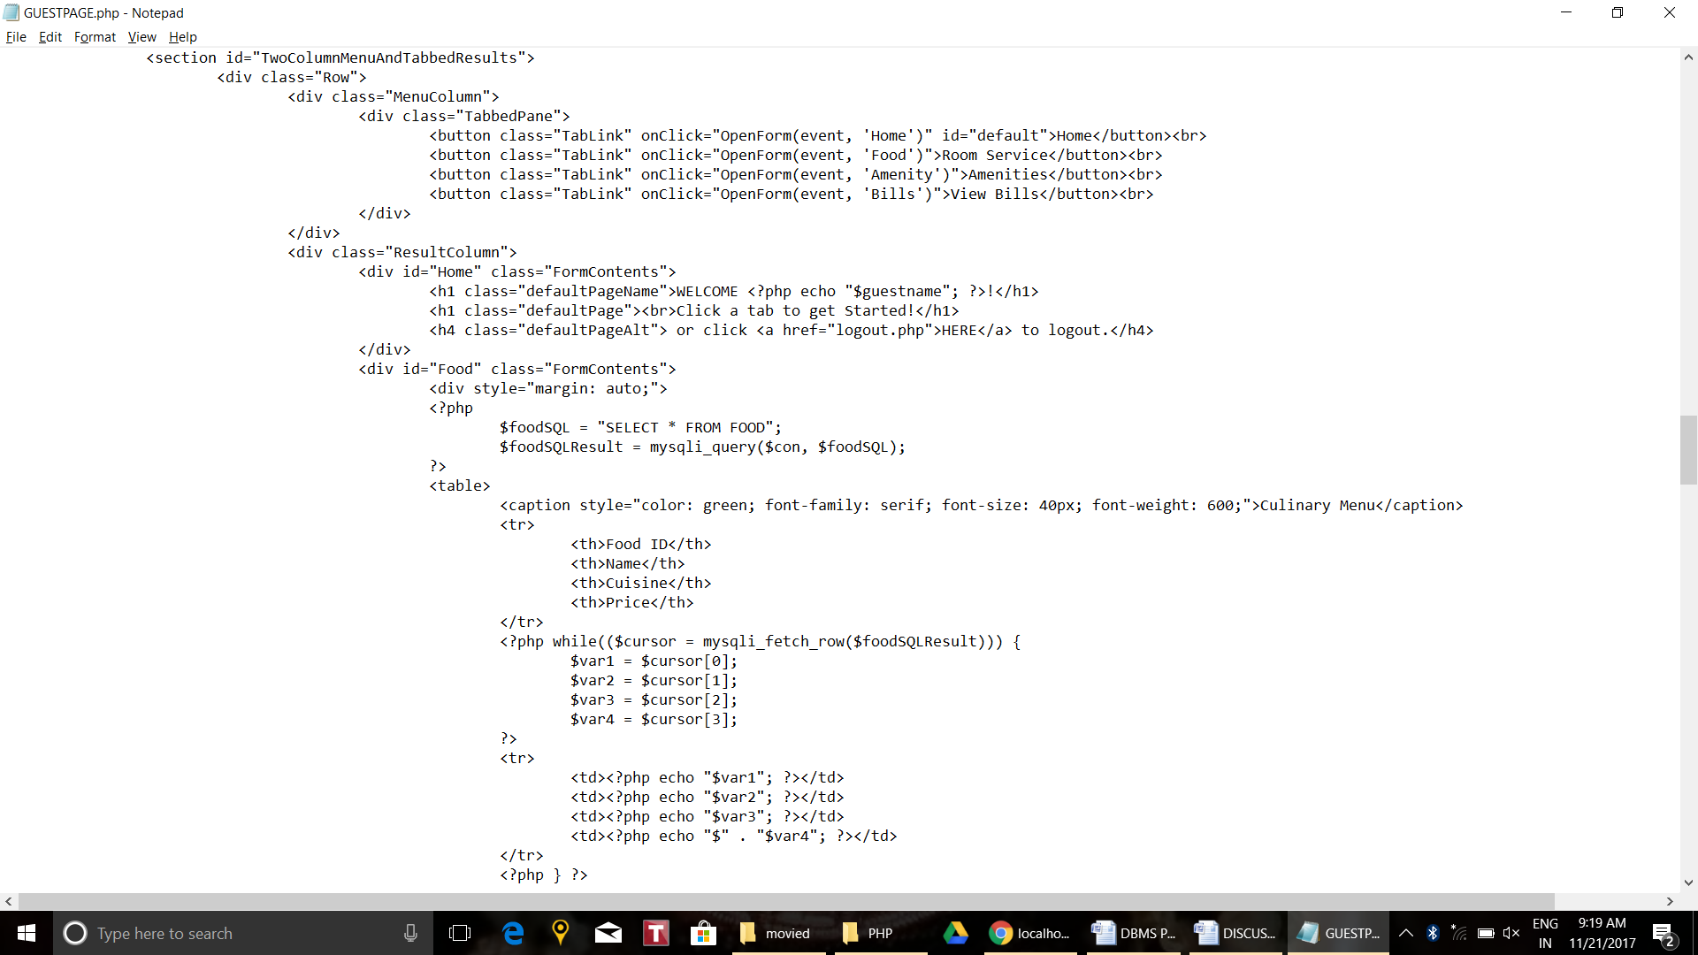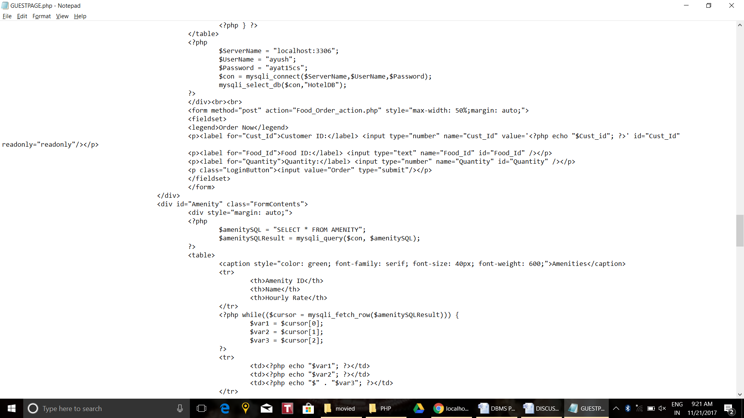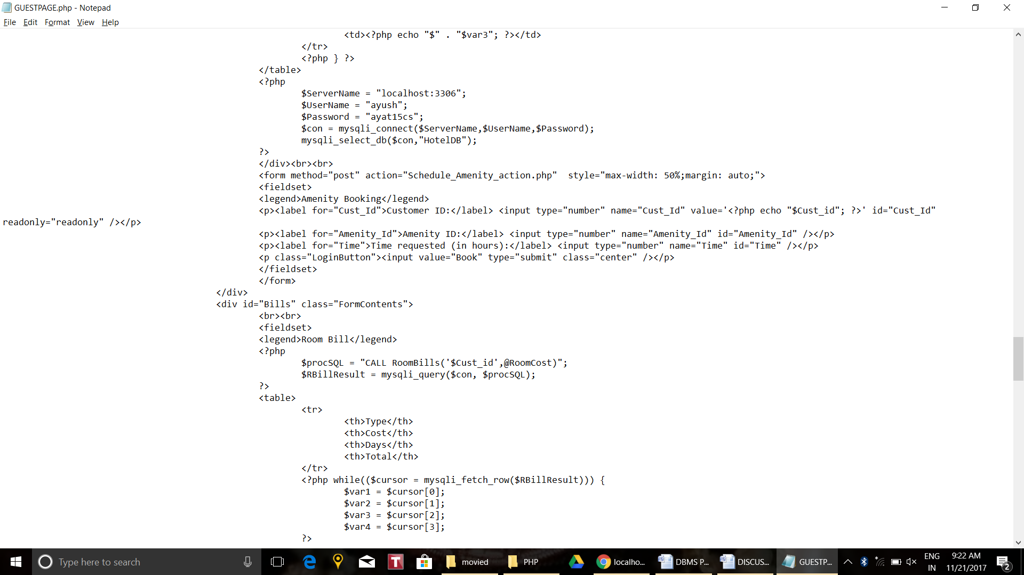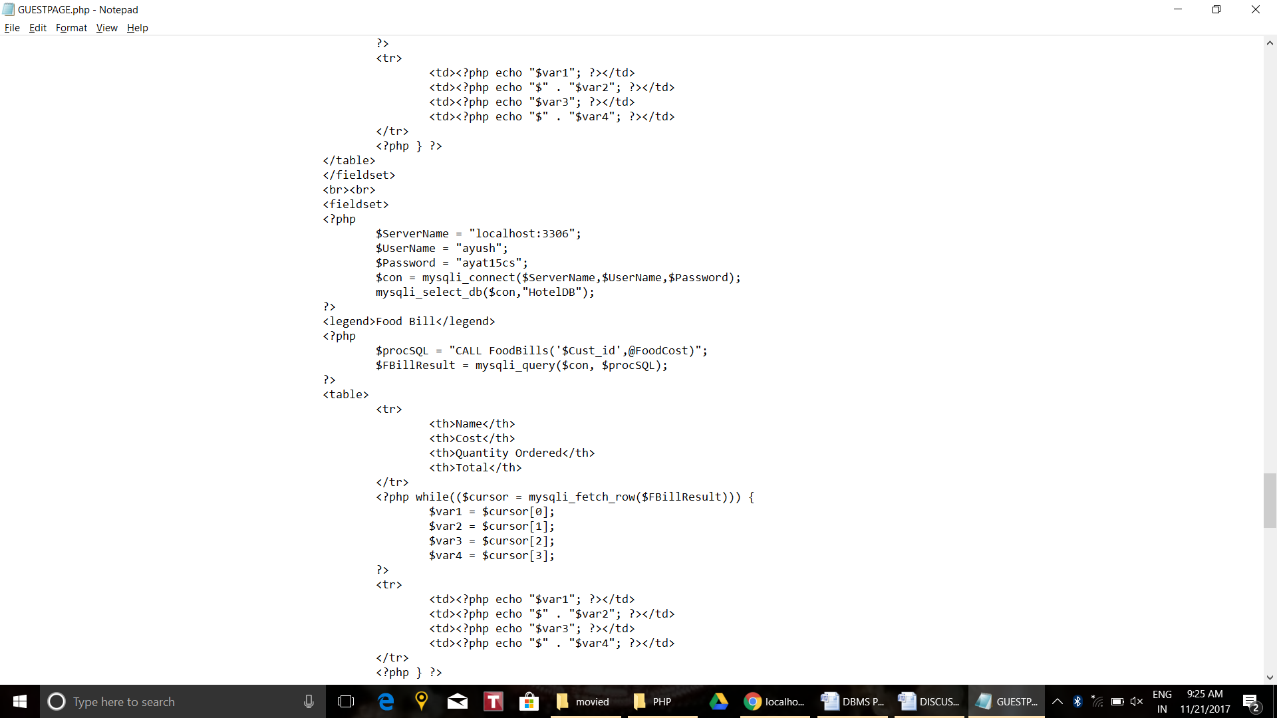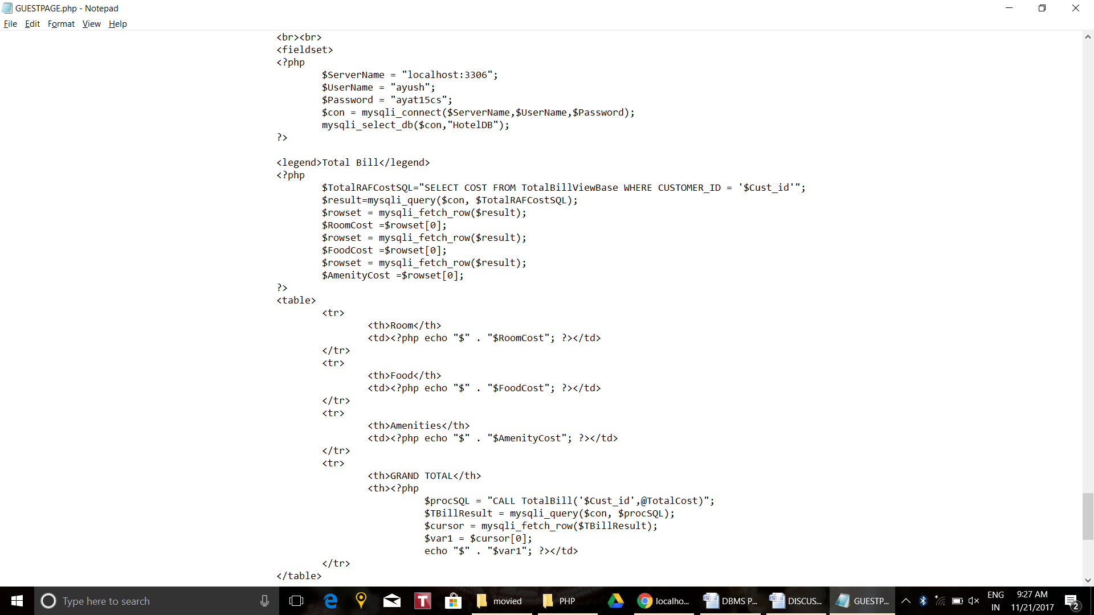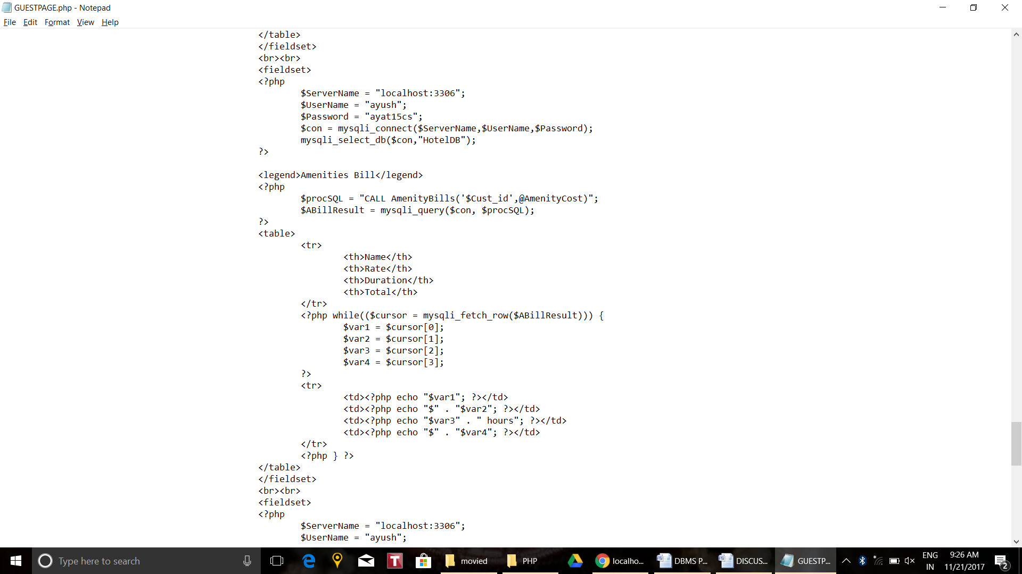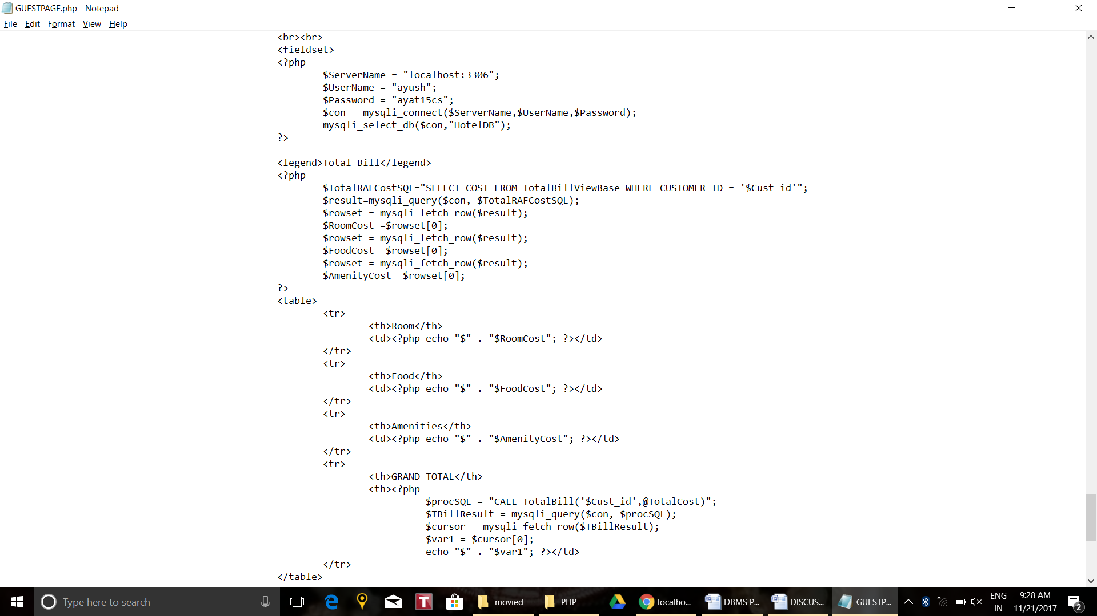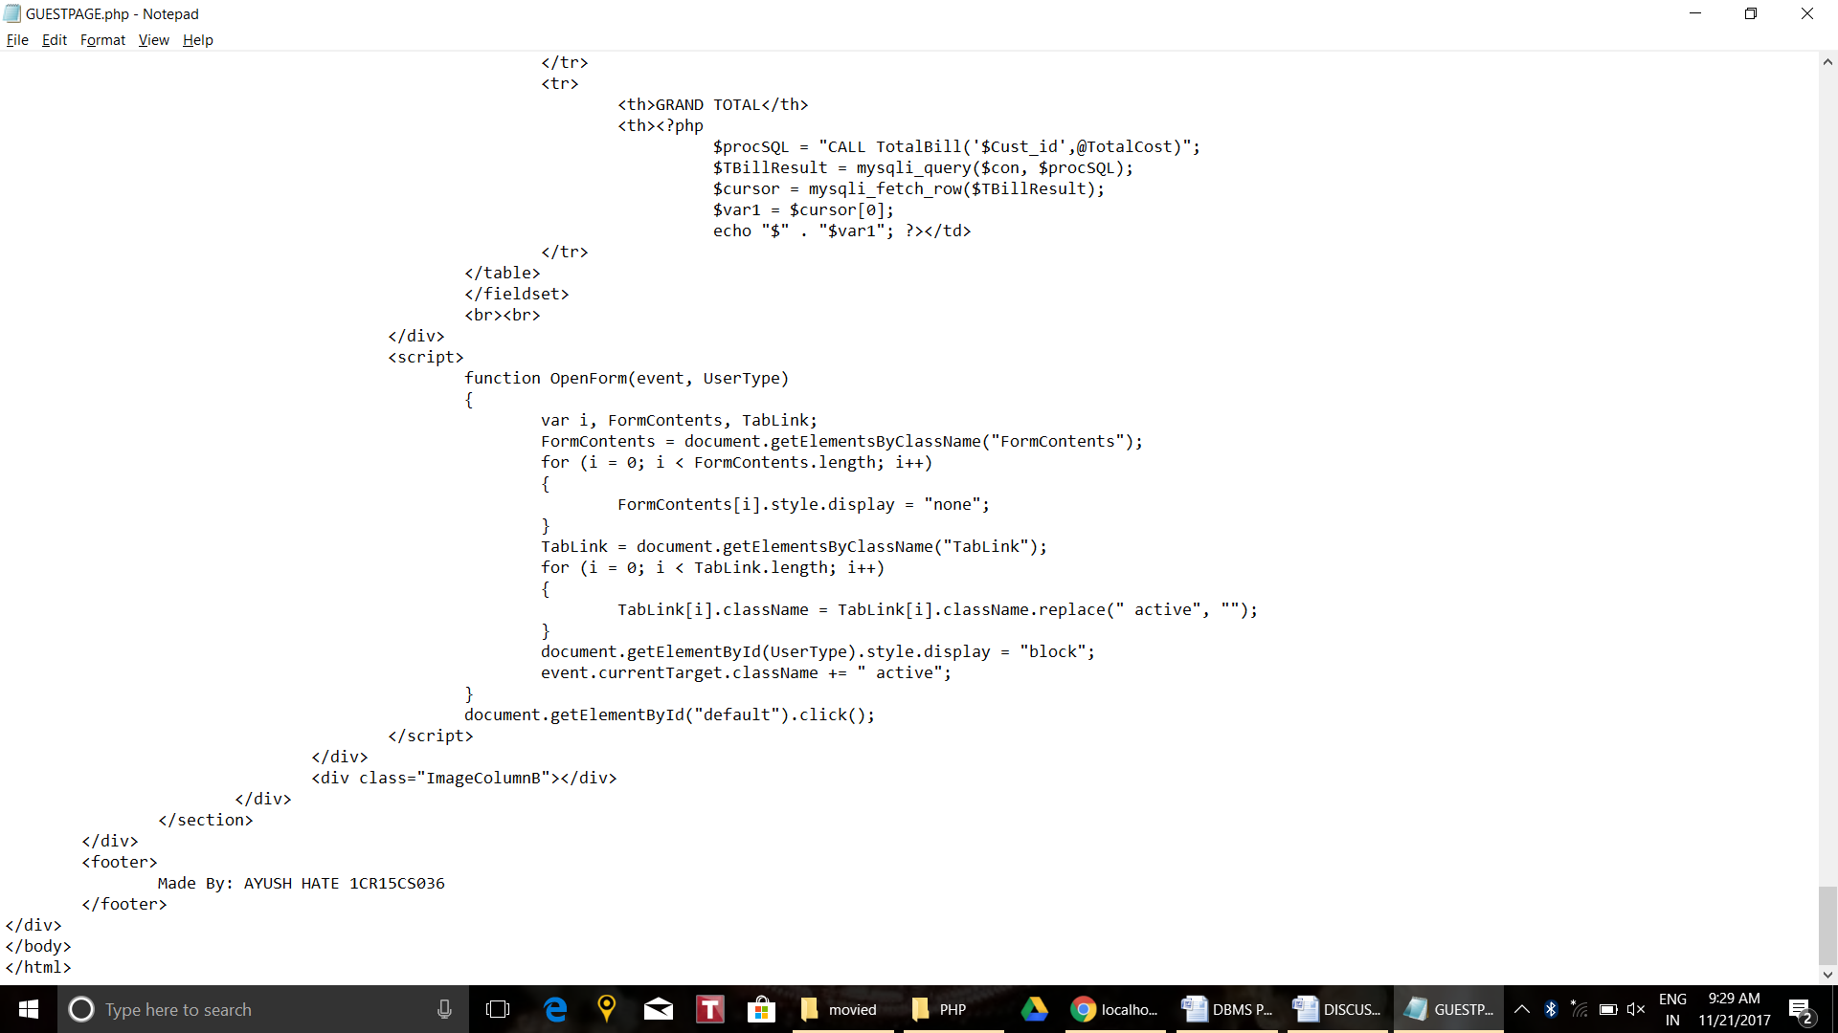

* + 1. **PHP**
    2. Including php files to connect to the Database and start a session:

1. Homepage:

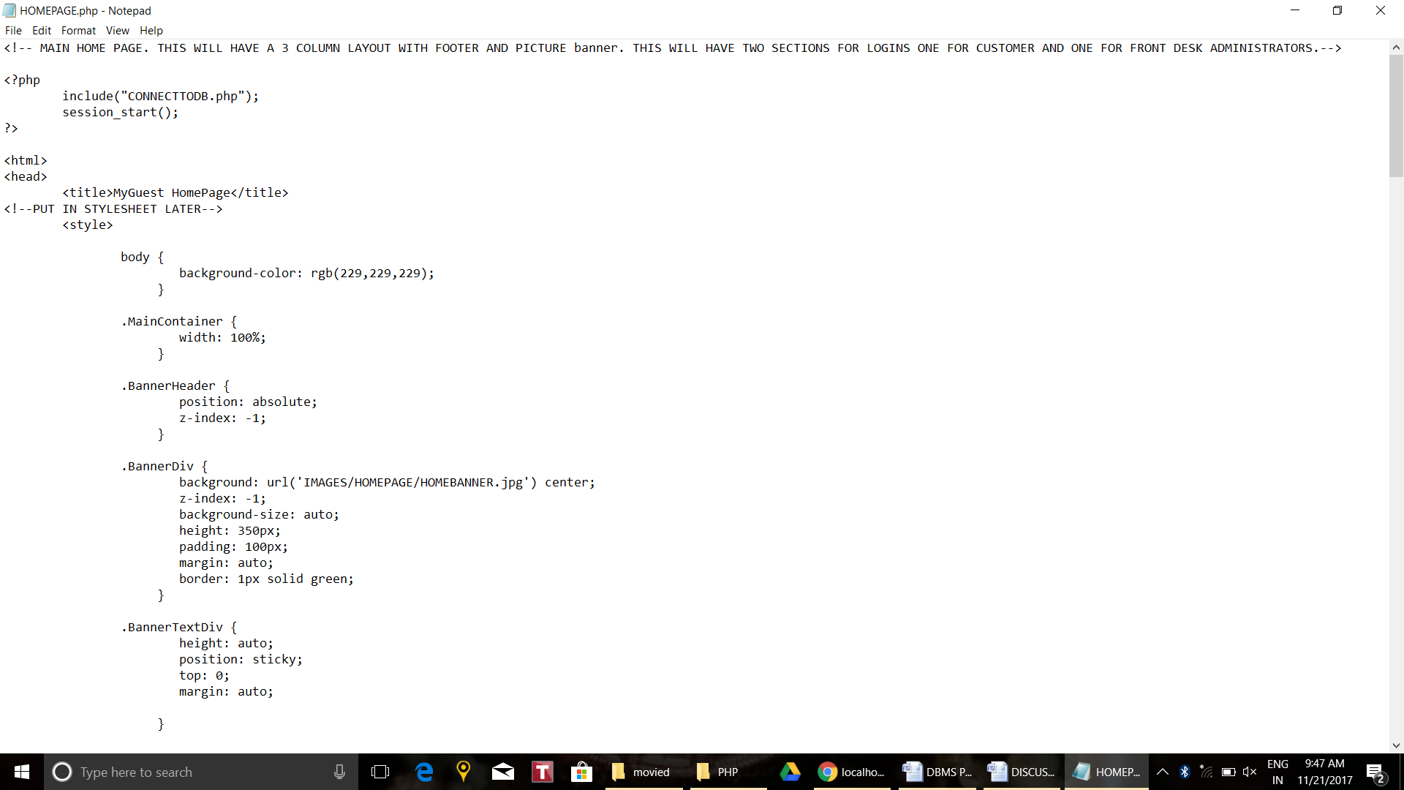

1. Admin Page:

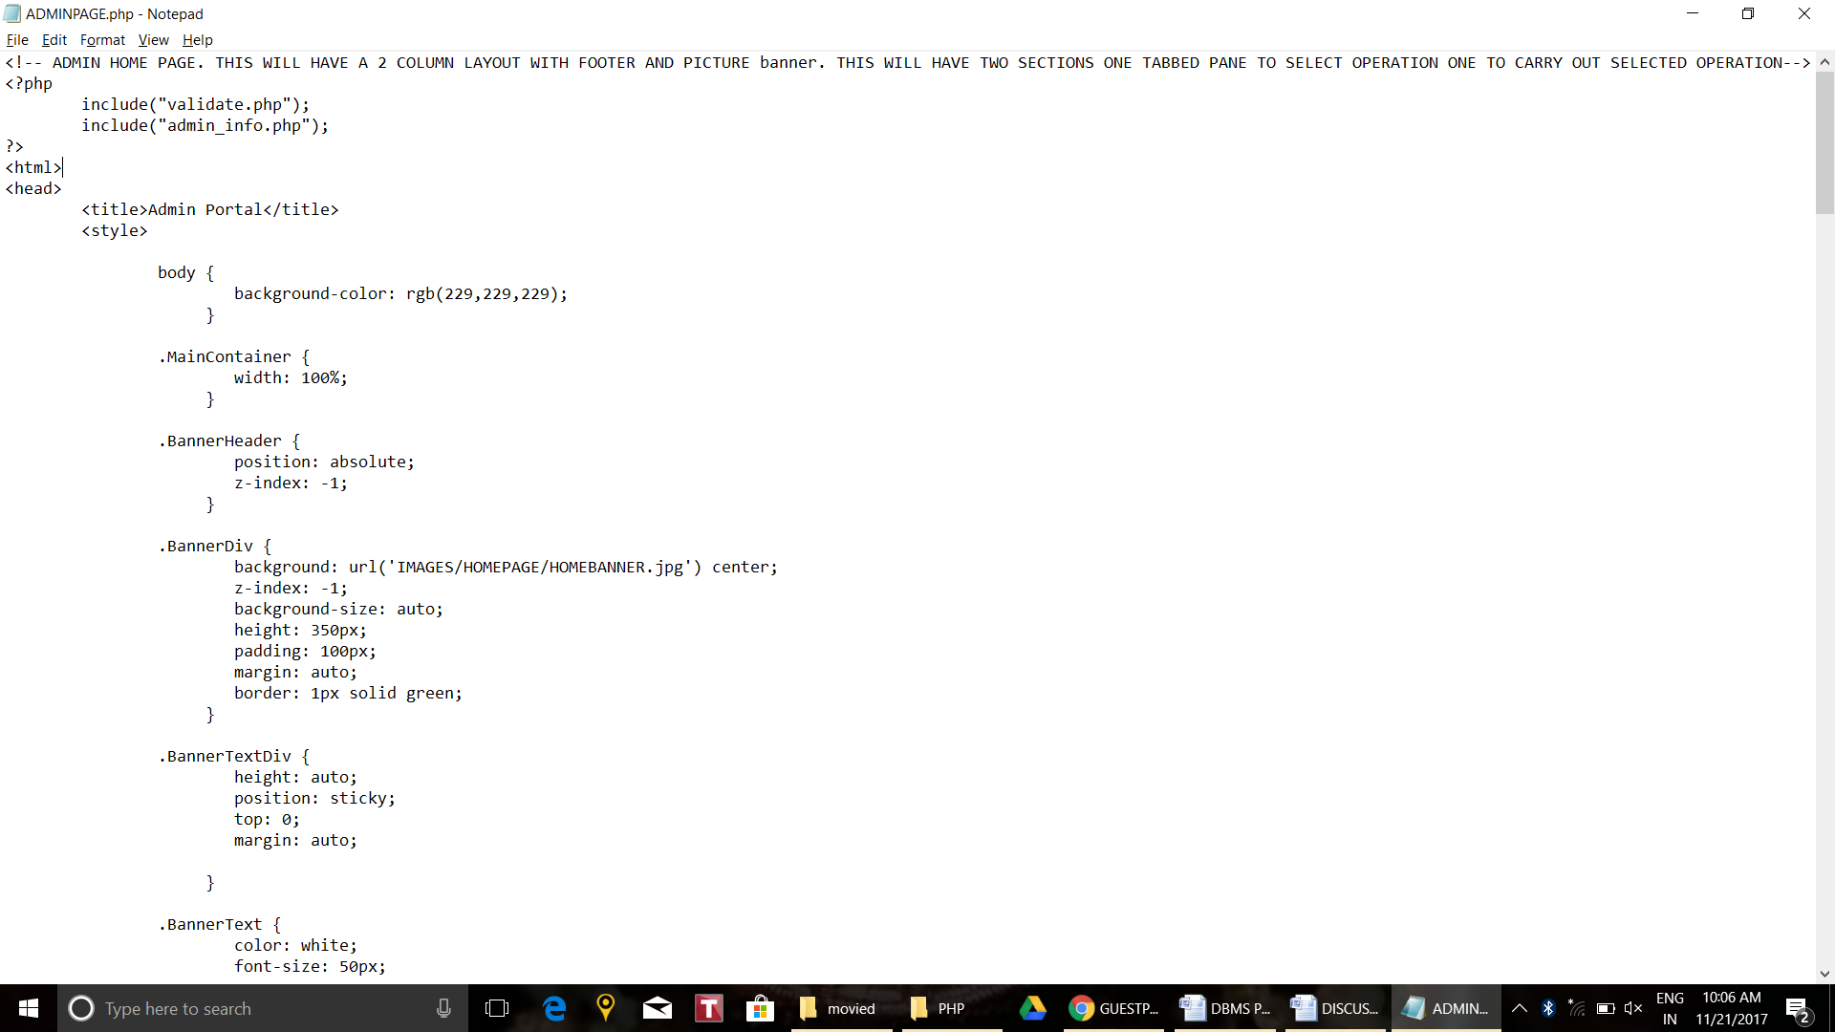

1. Guest Page:

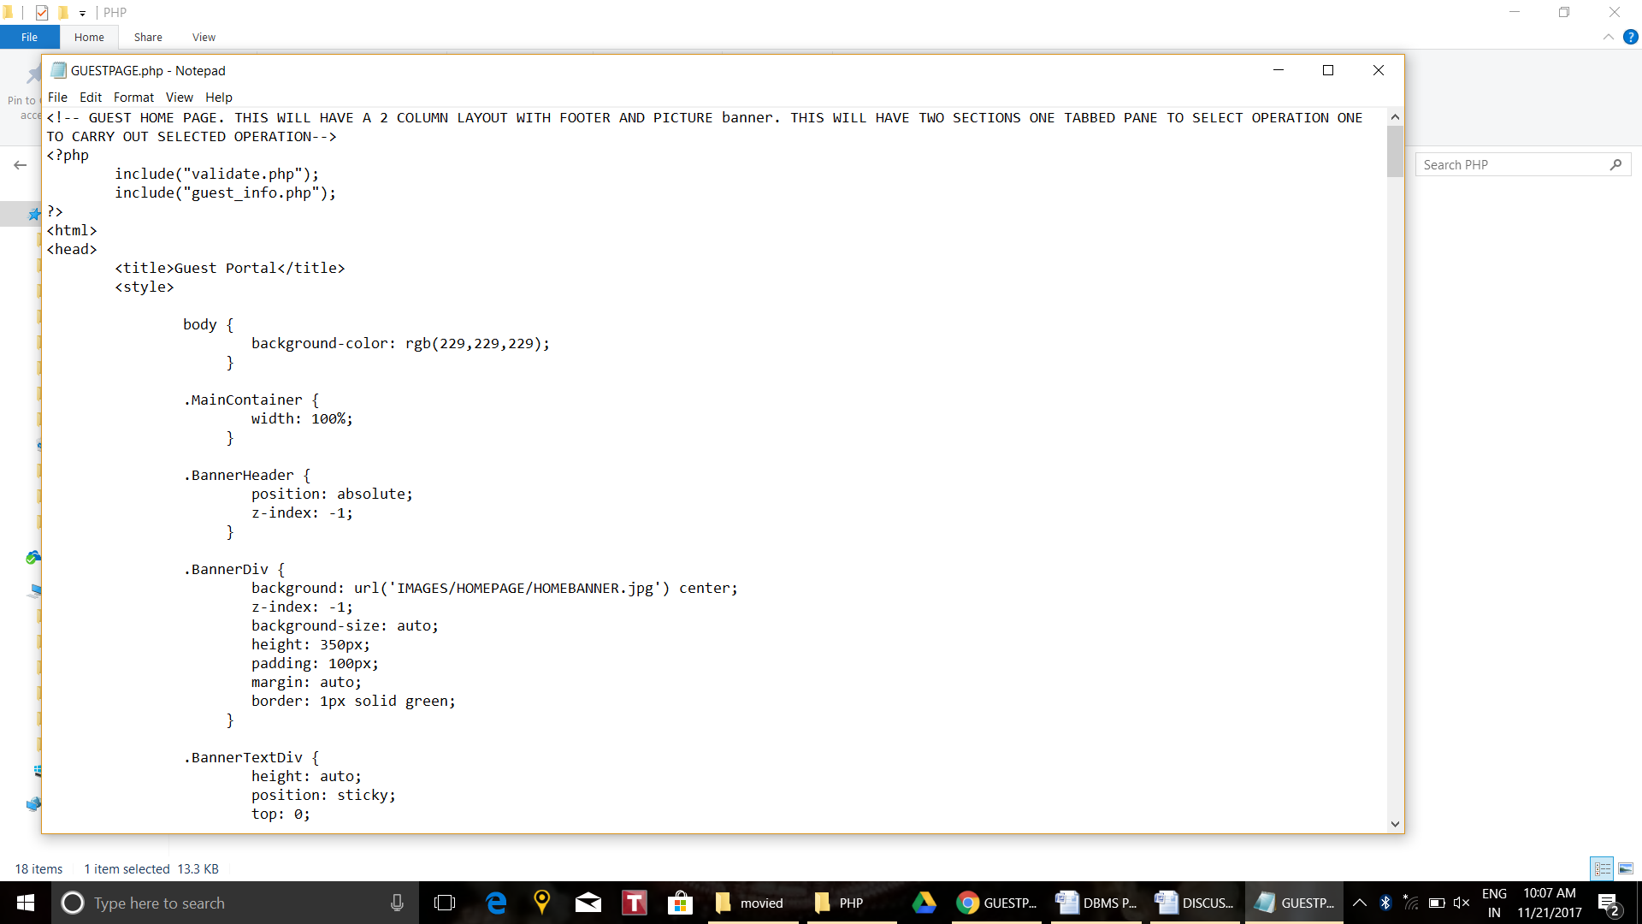

1. Connecting to The Database:

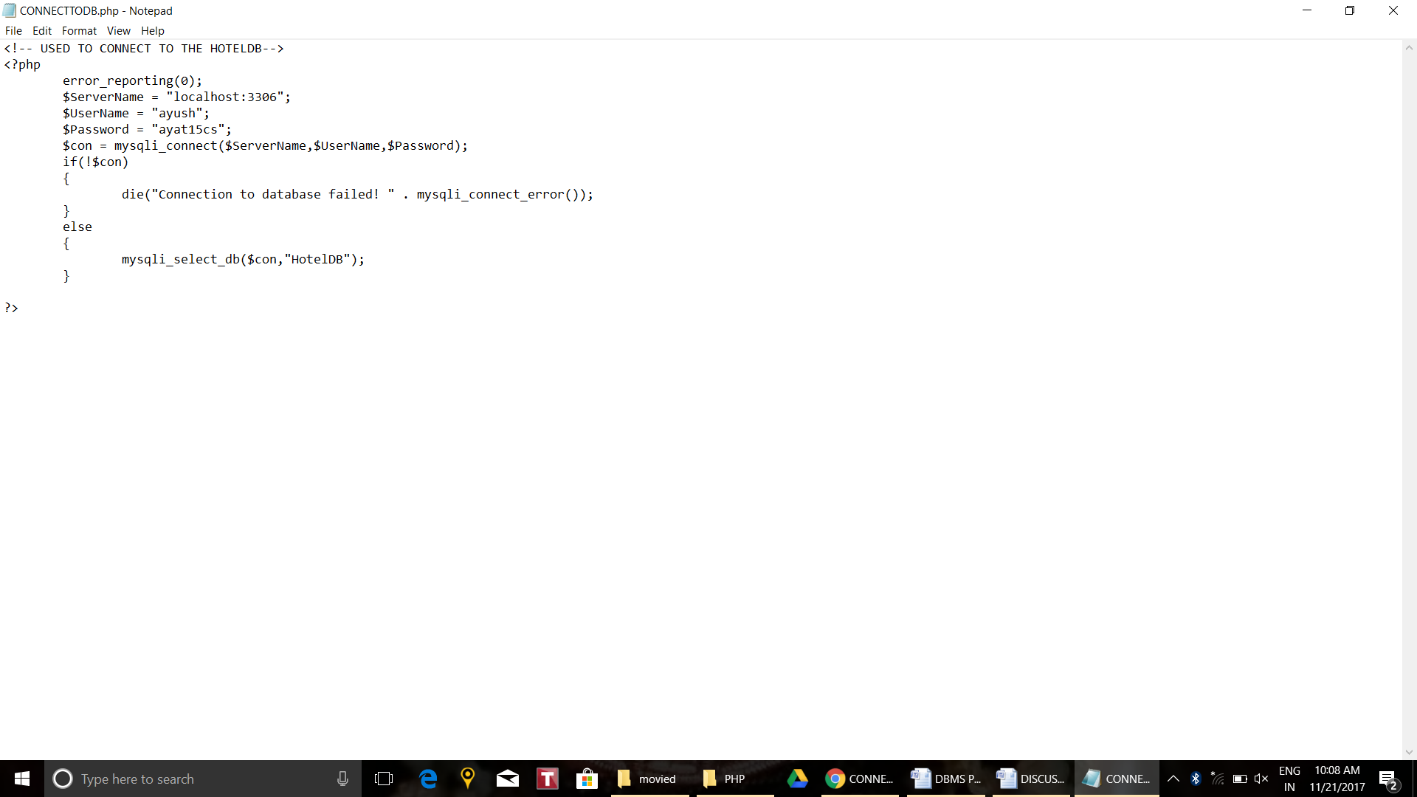

1. Validating Login:

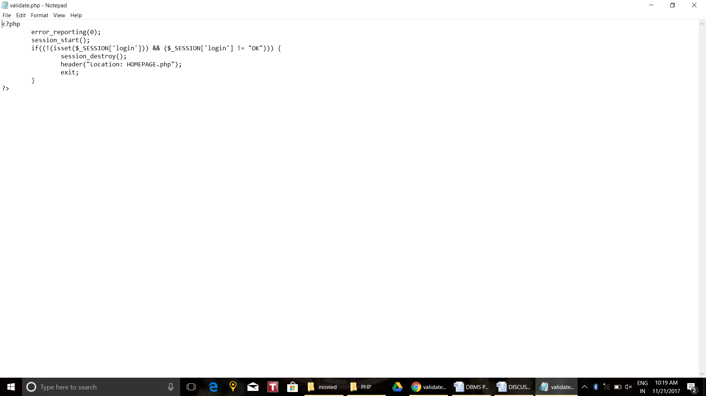

* + 1. Login Guest:

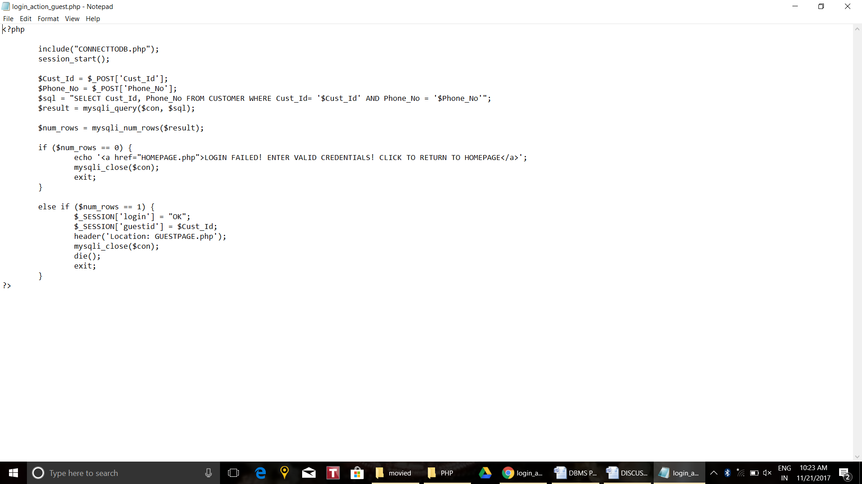

* + 1. Login Admin:

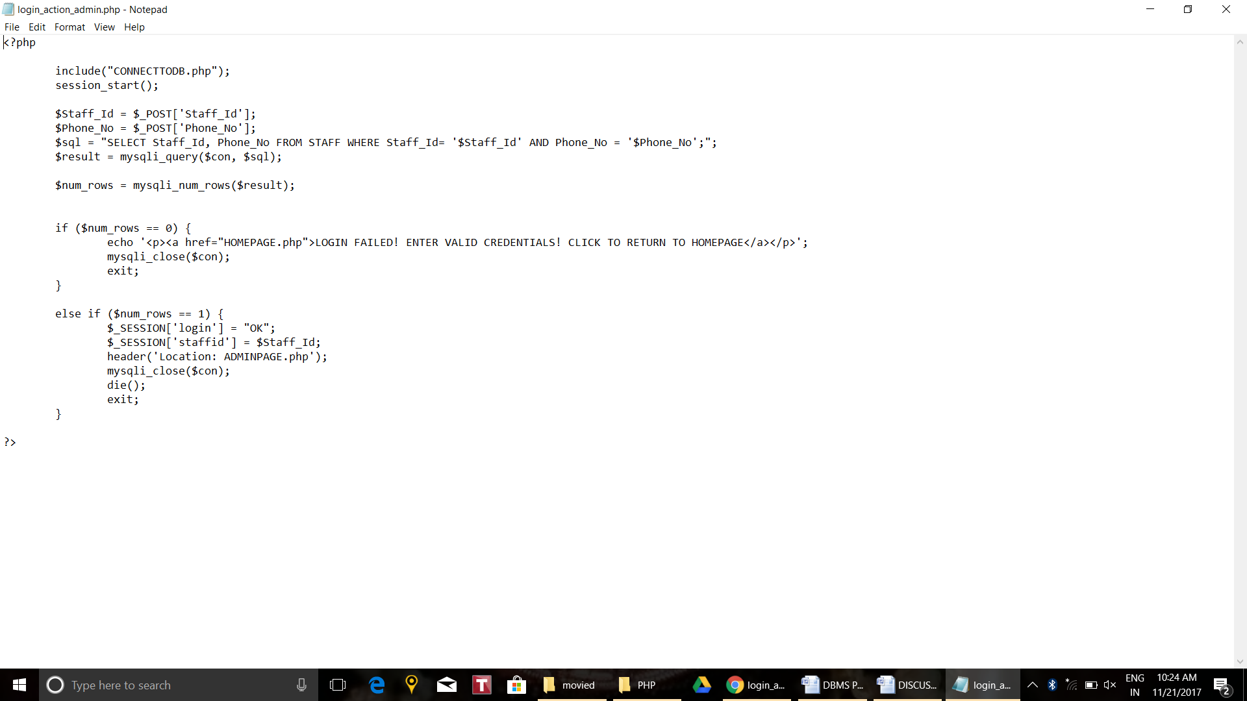

* + 1. Logout and destroying session:

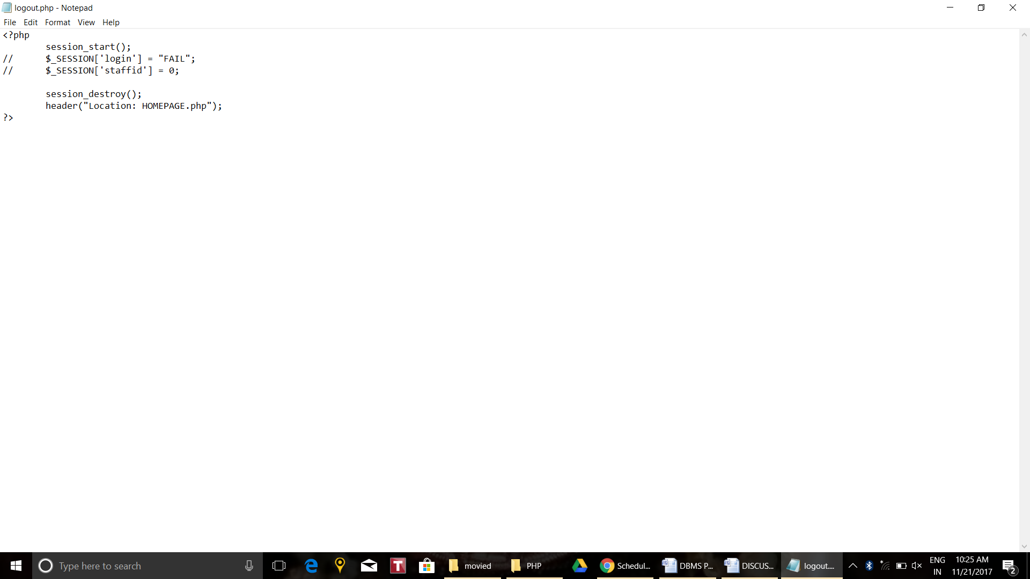

* + 1. GuestPage Functions:

1. Food Order:

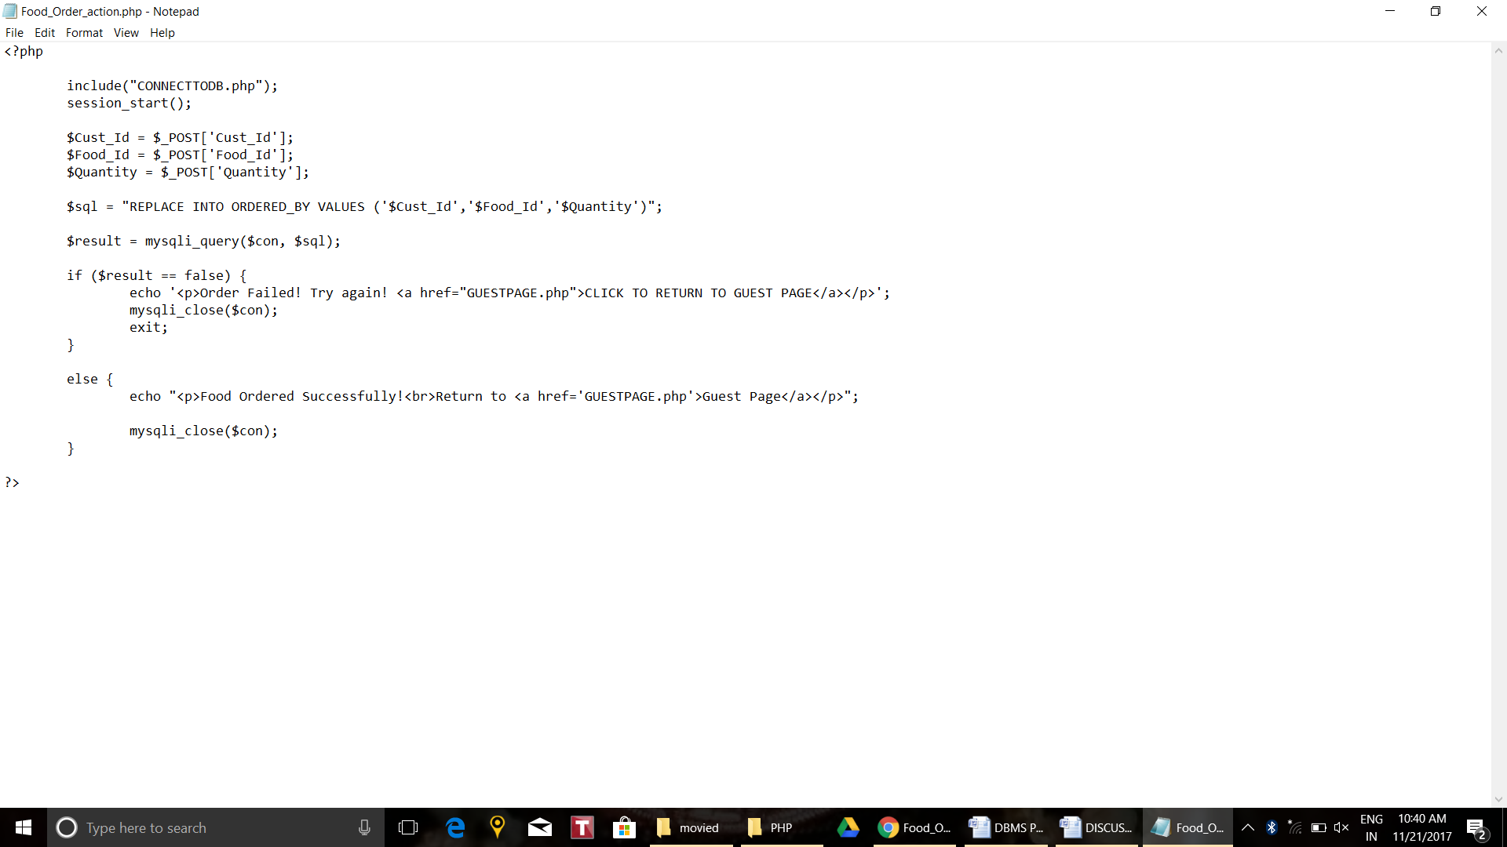

1. Amenity Bookings:

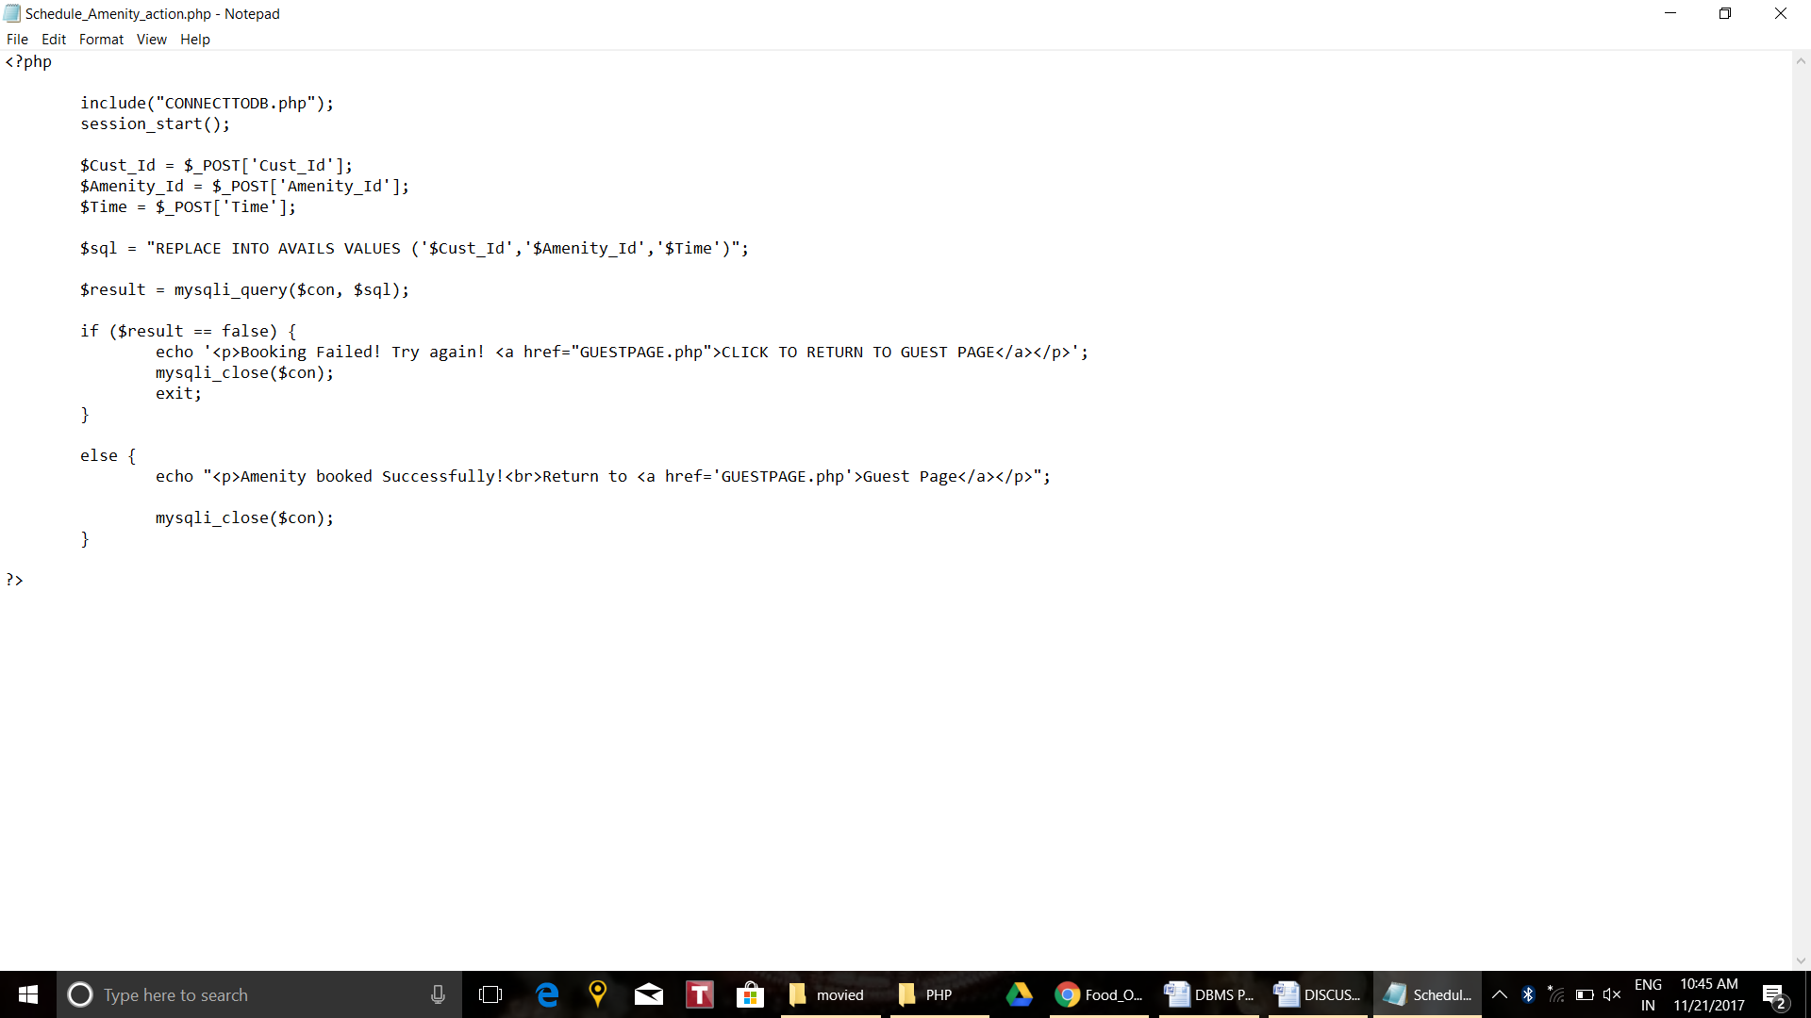

* + 1. AdminPage Functions:

1. Book Room:

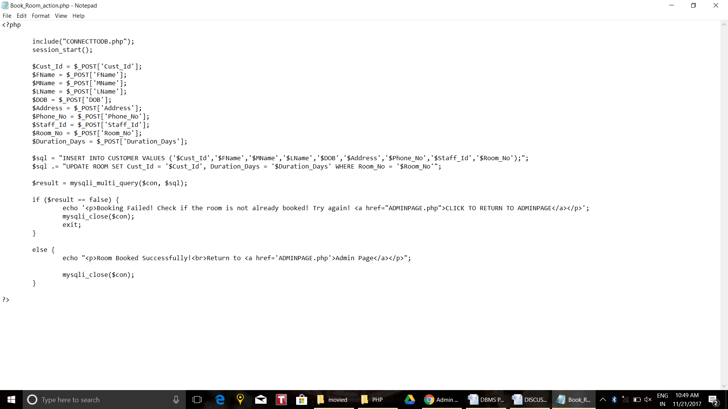

1. Check Out:

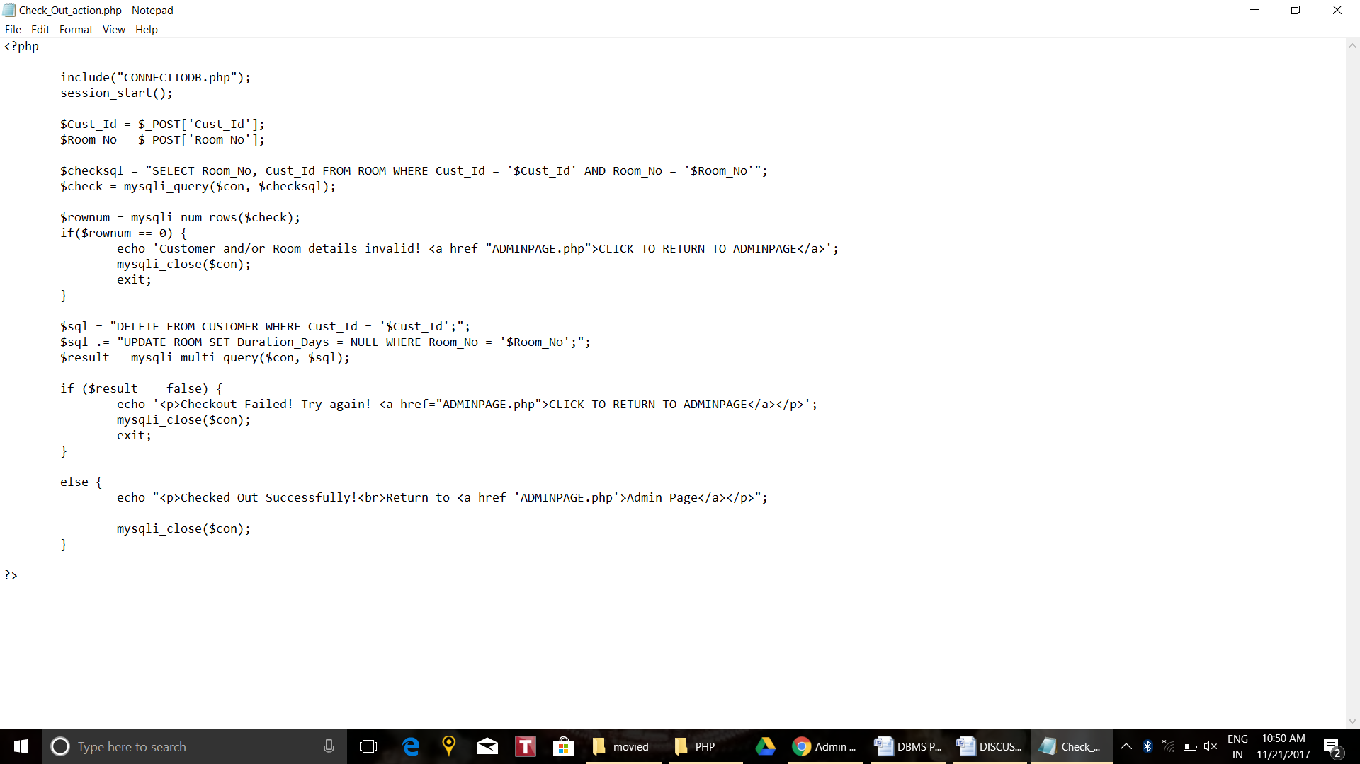

**Chapter 5**

**DISCUSSION AND SCREENSHOTS**

* 1. **Home Page:**

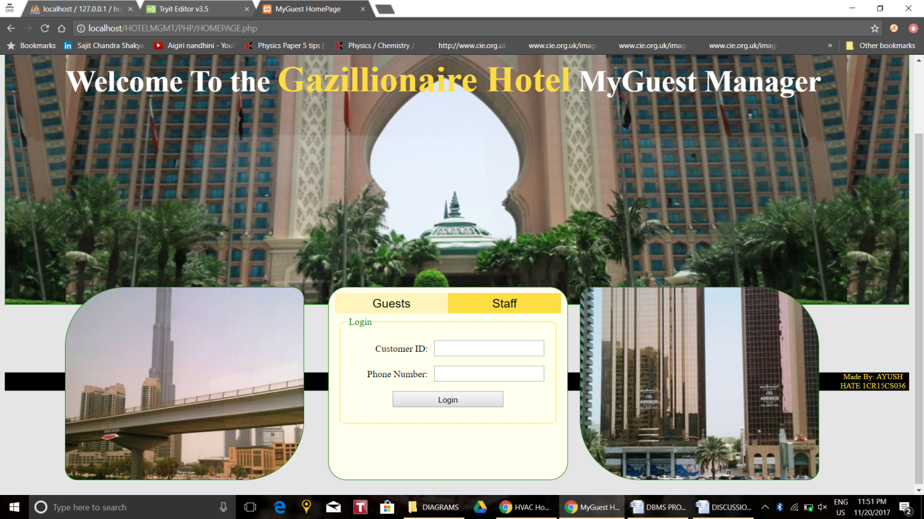**Fig 5.1 Login Page Guest Tab(default)**

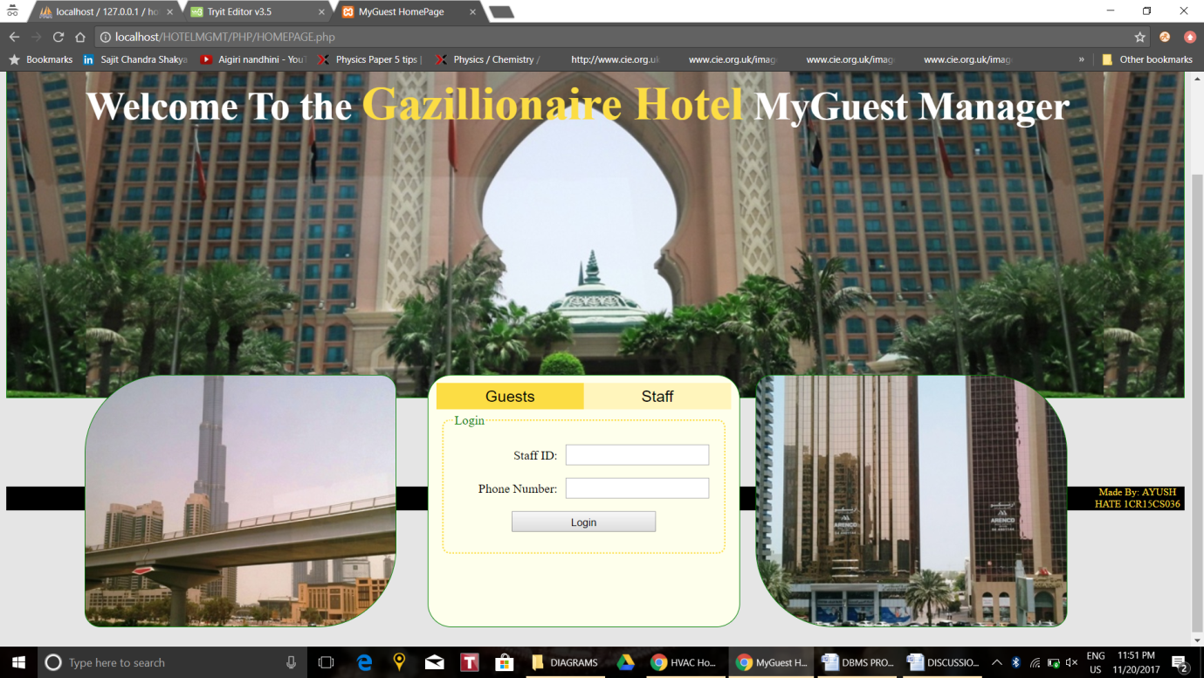

**Fig 5.2 Login Page Admin Tab**

The login page is a two tabbed login page which has one tab for guest login and the other for administrative staff such as front desk staff's login. One can navigate between the tabs by clicking on the required tab header. The login credentials are provided by the guest/admin id as the username and their phone number as the password. Pressing login logs the user into their respective portal page. This is achieved by checking against the database the entered combination of ID and Phone Number. If both are present, the user is logged in. The query to check this for guests is given in section **4.2.3** part **i-a.** The underlying PHP code which executes the query, redirects the user and initializes session variables is given in section **4.3.2** part **ii.** The query to login for admin is given in section **4.2.3** part **i-b.** The similar underlying PHP code is given in section **4.3.2** part **iii.** Refer section **4.3.1** part **i** for the underlying HTML.

Login Failure Error Reporting:

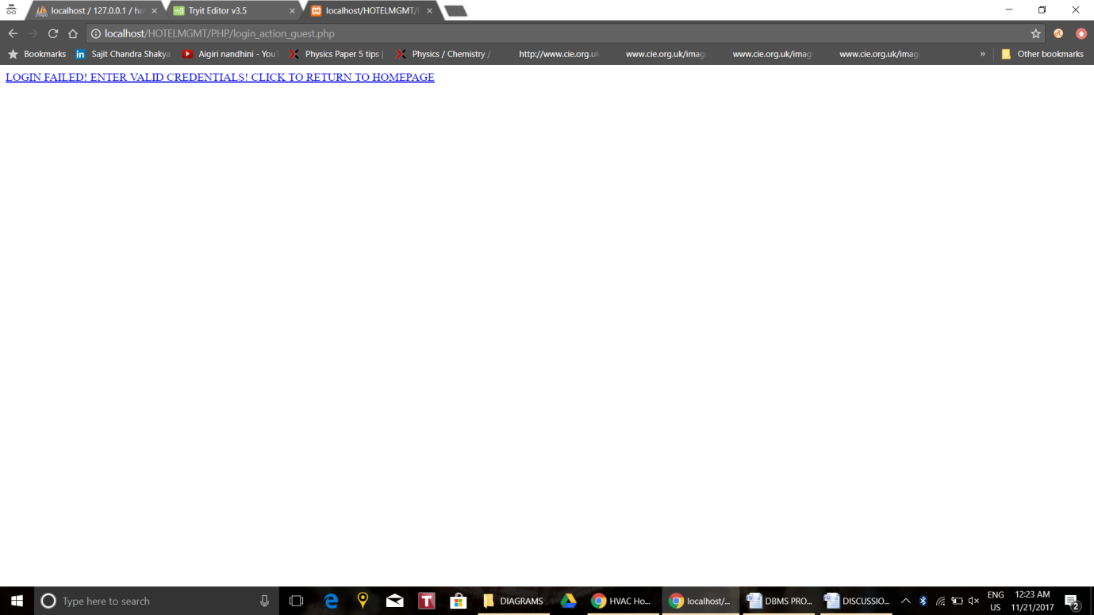

**Fig 5.3 Login Error**

On input of incorrect/incomplete credentials, the user is redirected to an error page as shown in **Fig 5.3**. This has a link back to the homepage. Validation is provided so a user, without logging in cannot manually type in /guestpage.php or /adminpage.php to visit those sites. They are automatically redirected to the homepage when there is no session started. This is implemented as in section **4.3.2 part i-e**.

* 1. **Guest Portal:**
     1. **Main Page:**

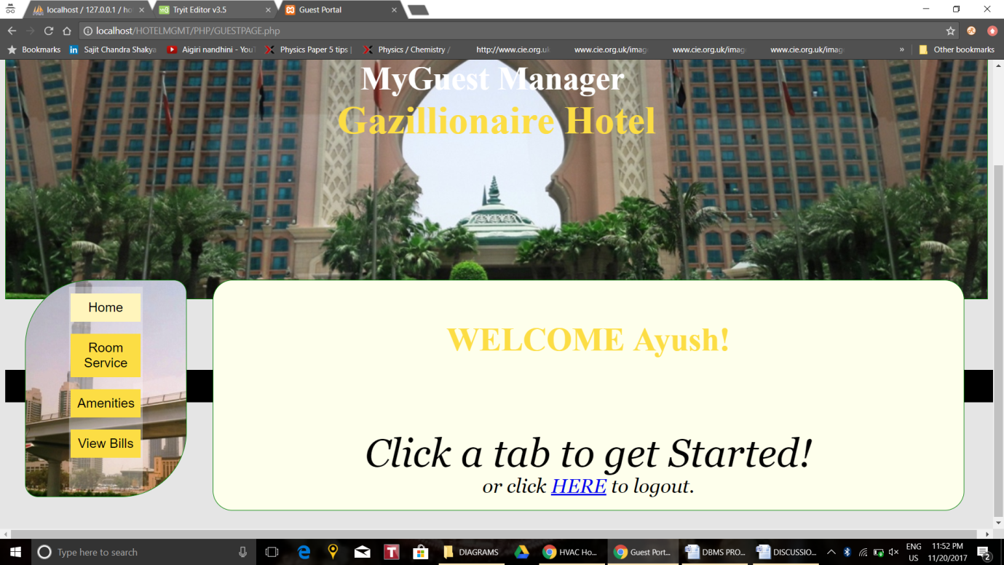

**Fig 5.4 Guest Homepage**

The Guest's homepage is the default tab opened when the /guestpage.php page is visited. It welcomes the guest with their name. This functionality is provided by querying the database using the login credential Cust_Id which the user used to login with and retrieving the user's name. The query used is in section **4.2.3** query **ii-a**.

The logout anchor is used to logout of the portal and return to the homepage. The PHP given in section **4.3.2** part **iv** takes care of this and closes the database connection, destroys session variables and redirects the user to the homepage.

* + 1. **Room Service Page:**

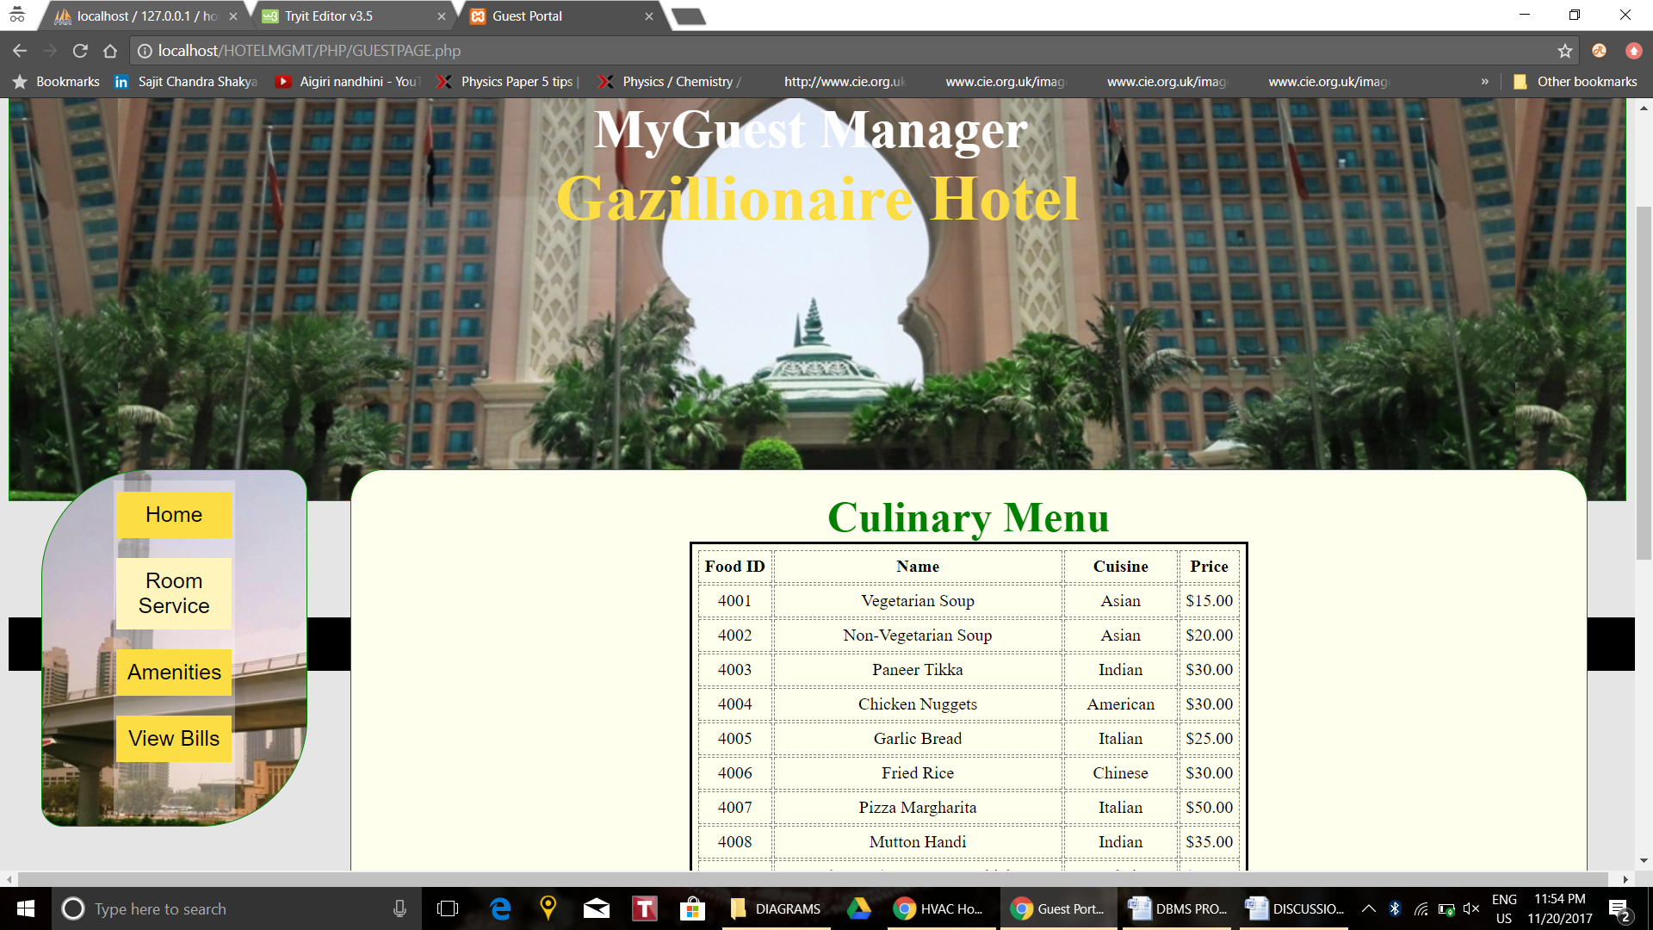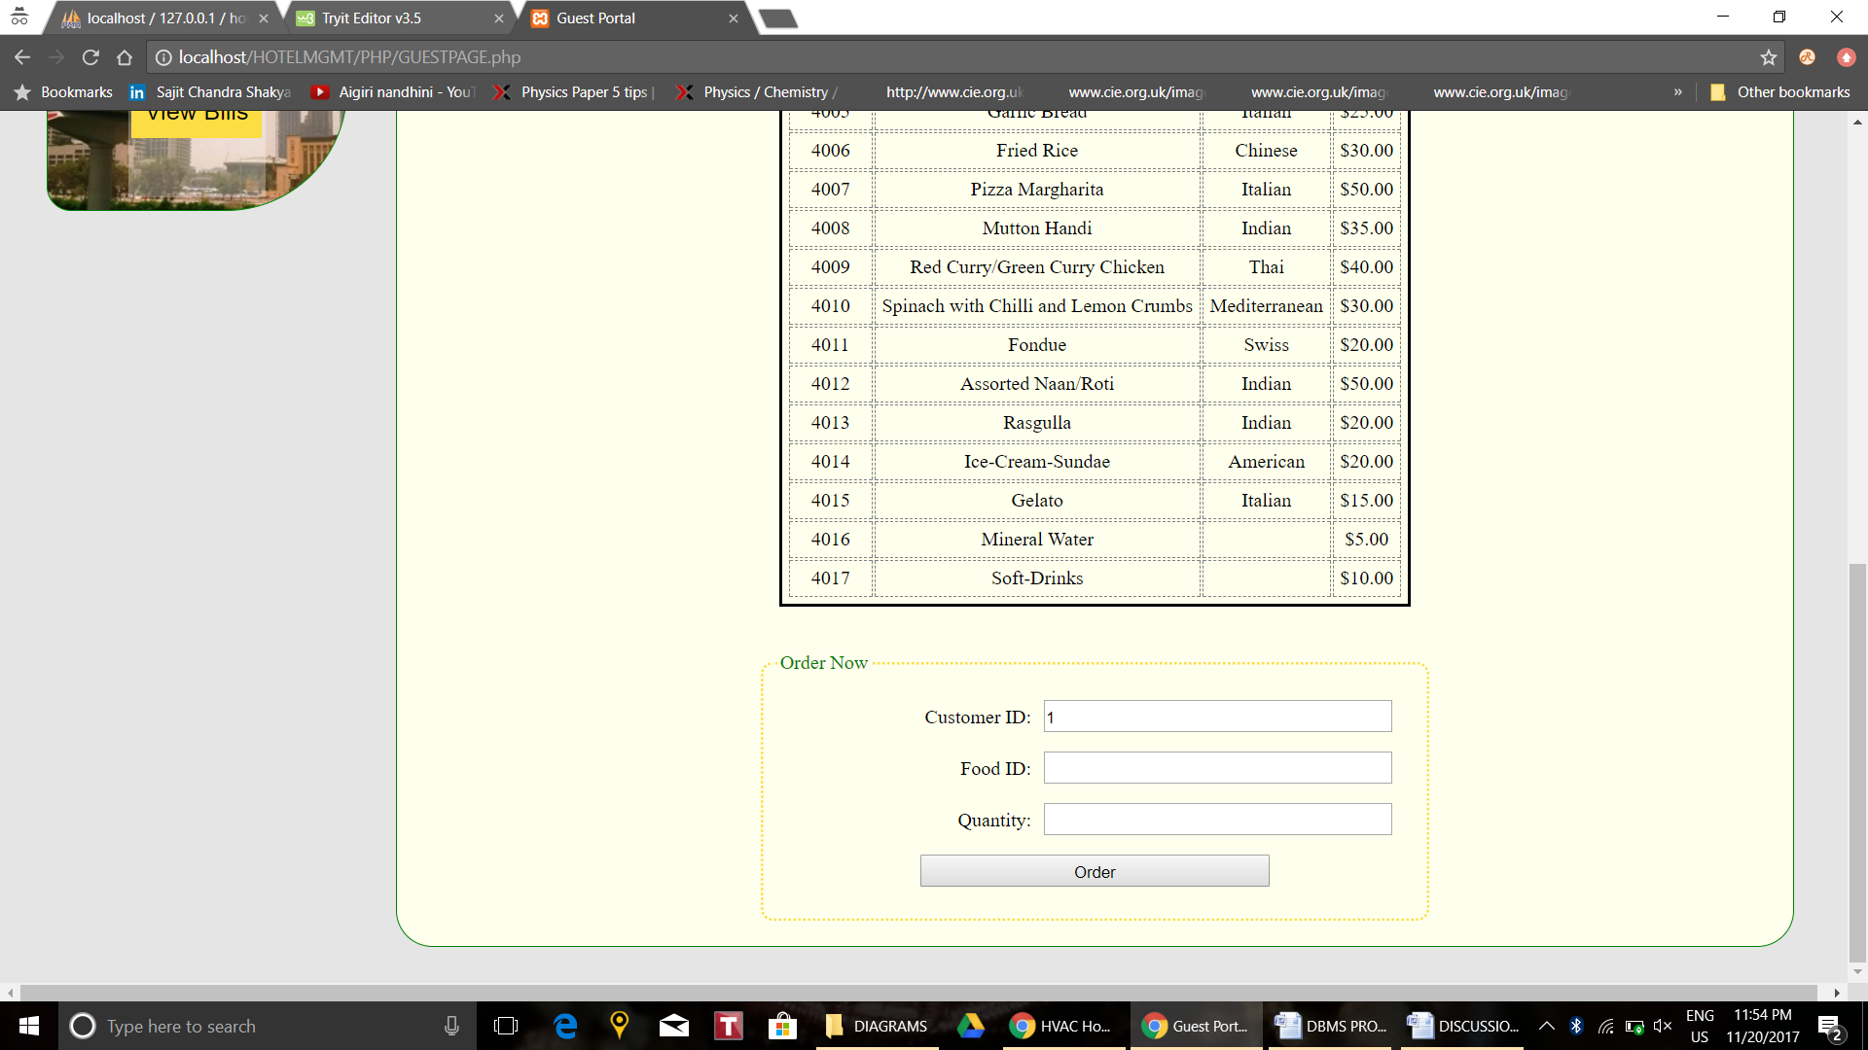

**Fig 5.5 Food Ordering Page**

The Room Service page displays the menu of food items that the customer can order. This is done by querying the database in PHP and then processing the result set row wise, setting the cursor at each result row, and putting each individual row element into a <td> table data item in the webpages HTML. The query used to retrieve data is a simple **SELECT * FROM FOOD**. The result set is processed and displayed as given in section **4.3.1** part **iii - guest page**, yielding the table as seen in **Fig 5.5**. The customer ID field is set to "readonly" to prevent user errors. It is preset to the Customer ID of the logged in guest.

The actual ordering process involves inserting the entered Food_Id and Quantity into the database. This is done using the queries in section **4.2.3** part **iii-a,** and executed using thePHP as in section **4.3.2** part **v-a.** The ordering process query activates the trigger given in section **4.2.5** part **i.** This trigger prevents the duplicate entry of Food ID and Customer ID into the **ORDERED_BY** table where those fields are a composite key. Instead, it checks whether that tuple is present and if it is, it adds the new quantity with the existing quantity. This aids in calculating the final cost to the customer for ordering that food and enables them to order it multiple times without causing error and redundancy in the database.

Choosing incorrect Food ID/Quantity combinations results in an error message as in **Fig 5.6** with a link back to the guest page.

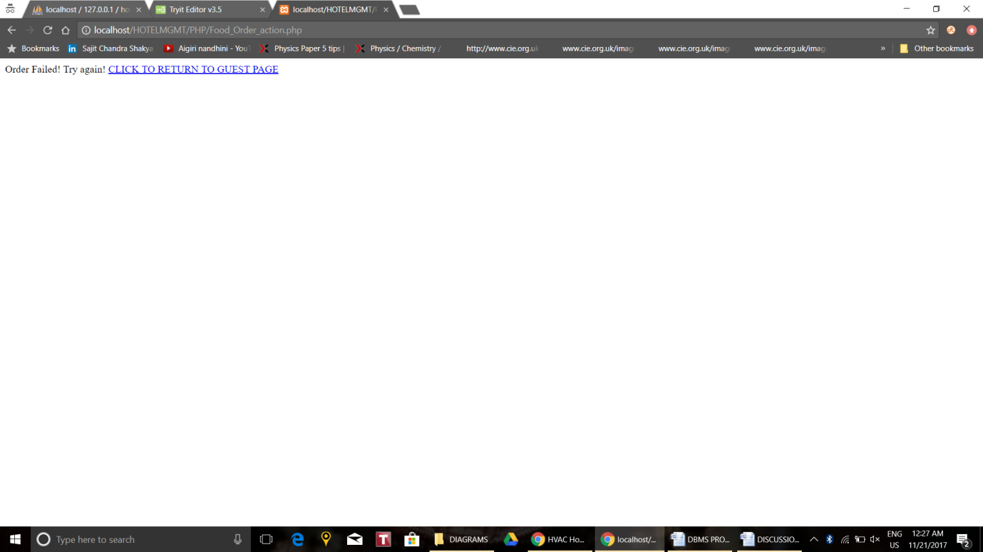

**Fig 5.6 Food Order Failure**

* + 1. **Amenity Booking Page:**

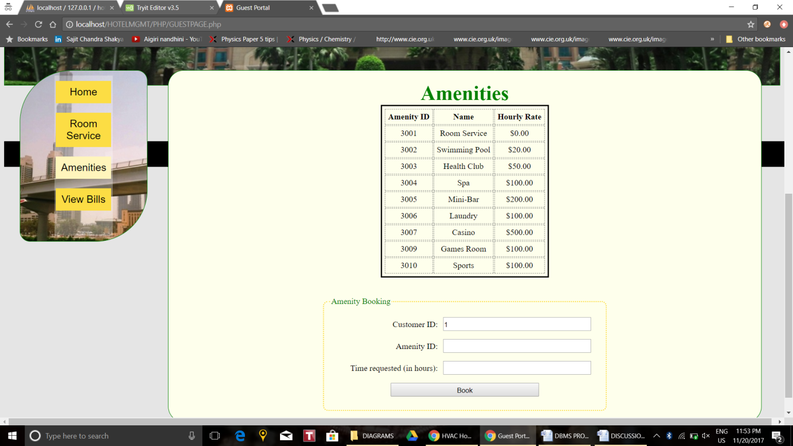

**Fig 5.7 Amenity Booking Tab**

The Amenities page displays a list of amenities and their rates offered at the Gazillionaire Hotel. This is achieved by querying the database in PHP and then processing the result set similar to the method used in Room Booking page (section **5.2.2**). The query used to retrieve data is a simple **SELECT * FROM AMENITY**. The result set is processed and displayed as given in section **4.3.1** part **ii - admin page**, yielding the table as seen in **Fig 5.7**. The customer ID field is set to "read-only" to prevent user errors. It is preset to the Customer ID of the logged in guest.

The actual booking process is similar to the food ordering process as in section **5.2.2** using the queries in section **4.2.3** part **iii-b,** and executed using thePHP as in section **4.3.2** part **v-b.** The booking process' query activates the trigger given in section **4.2.5** part **ii.** This trigger prevents the duplicate entry of Amenity ID and Customer ID into the **AVAILS** table where those fields are a composite key. Instead, it checks whether that tuple is present and if it is, it adds the new time with the existing time. This aids in calculating the final cost to the customer for availing that amenity and lets the guest book and avail that amenity multiple times without causing error and redundancy in the database.

Choosing incorrect Amenity ID/Duration combinations results in an error message with a link back to the guest page.

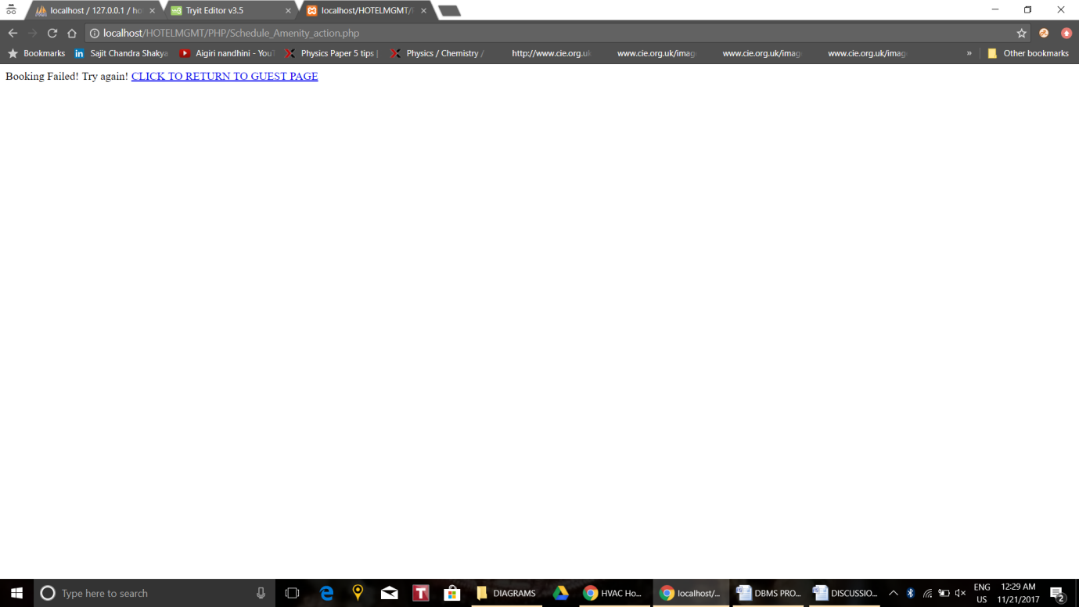

**Fig 5.8 Amenity Booking Error**

* + 1. **Bill Summary Page:**

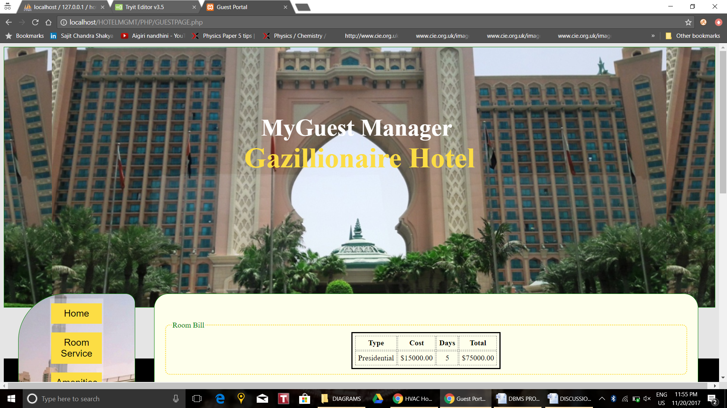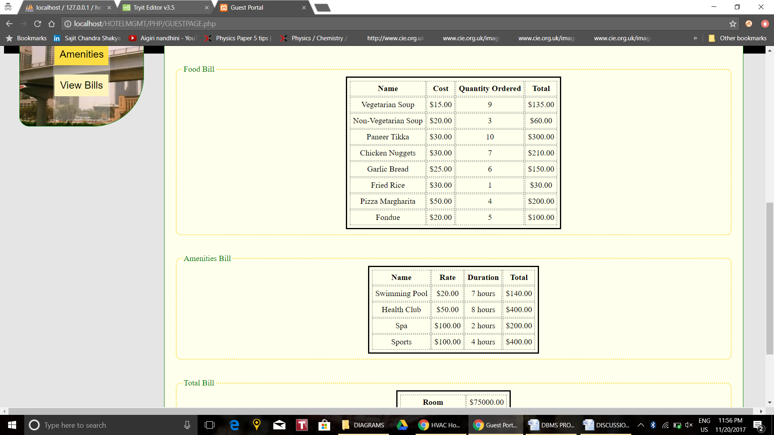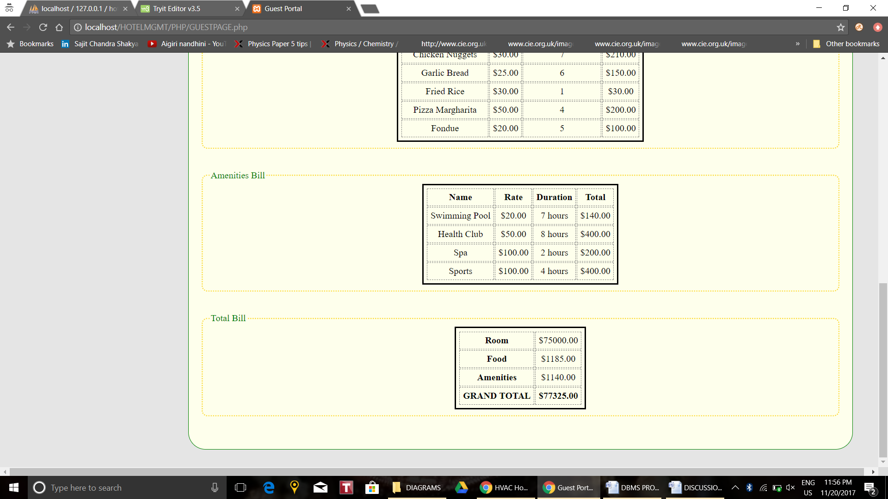

**Fig 5.9 Guest Invoice Summary**

The View Bills tab displays a itemized summary of the guest's expenses categorized into Room, Food, Amenities and Total Bill sections. The tables are populated by calling stored procedures given in section **4.2.4** parts **v, vi, vii, viii.** These stored procedures execute queries which return values stored in various views. These views are given in section **4.2.4** parts **i, ii ,iii ,iv.** These stored procedures are called by executing queries in section **4.2.3** part **iii-c and iii-d** in the PHP parts to process the result set (section **4.3.1** part **iii**) using the same method as populating the food menu in section **5.2.2.**

* 1. **Admin Portal:**
     1. **Main Page:**

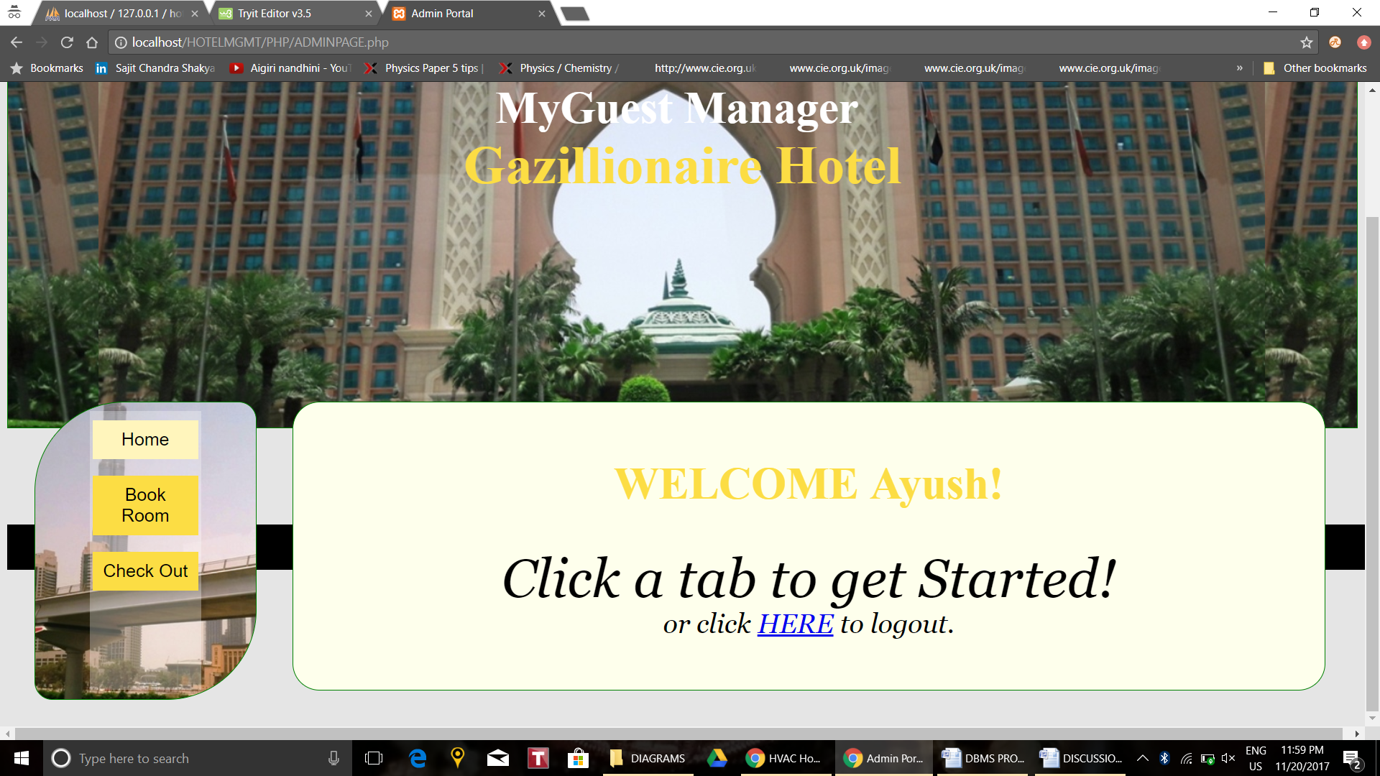

**Fig 5.10 Admin Homepage(default)**

The Staff member's home page is the default tab opened when the /adminpage.php page is visited. It welcomes the admin with their name like in the guestpage. This functionality is provided by querying the database using the login credential Staff_Id which the user used to login with and retrieving the user's name. The query used is in section **4.2.3** query **ii-b**.

The logout anchor is used to logout of the portal and return to the homepage. The PHP given in section **4.3.2** part **iv** takes care of this and closes the database connection, destroys session variables and redirects the user to the homepage.

* + 1. **Booking a Room Page:**

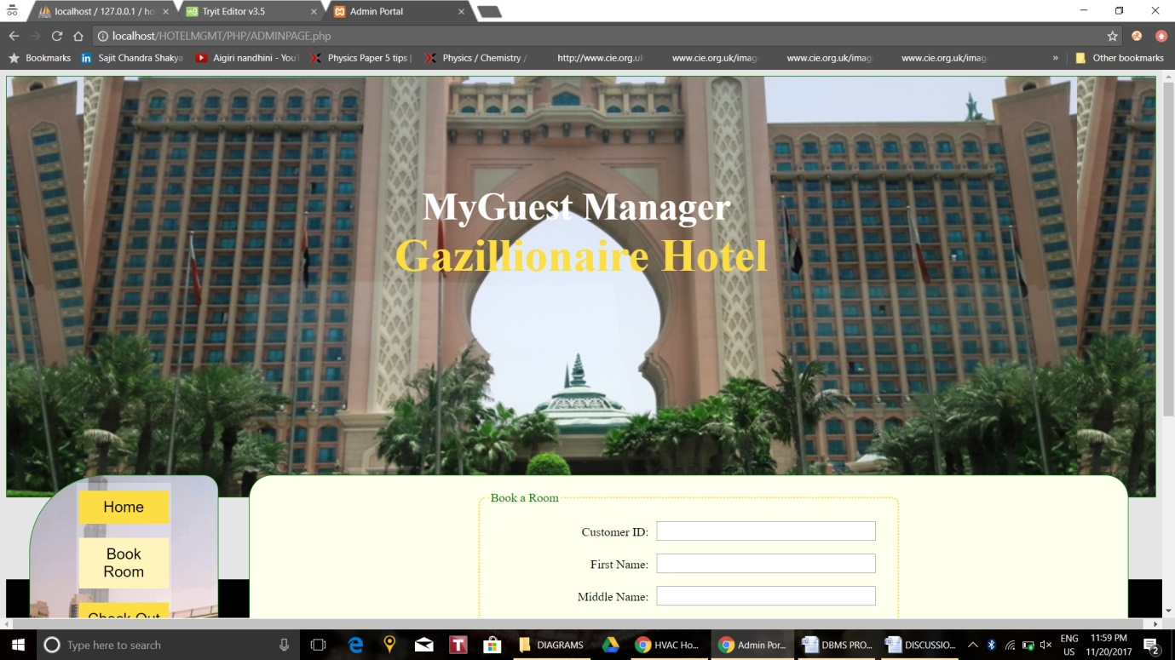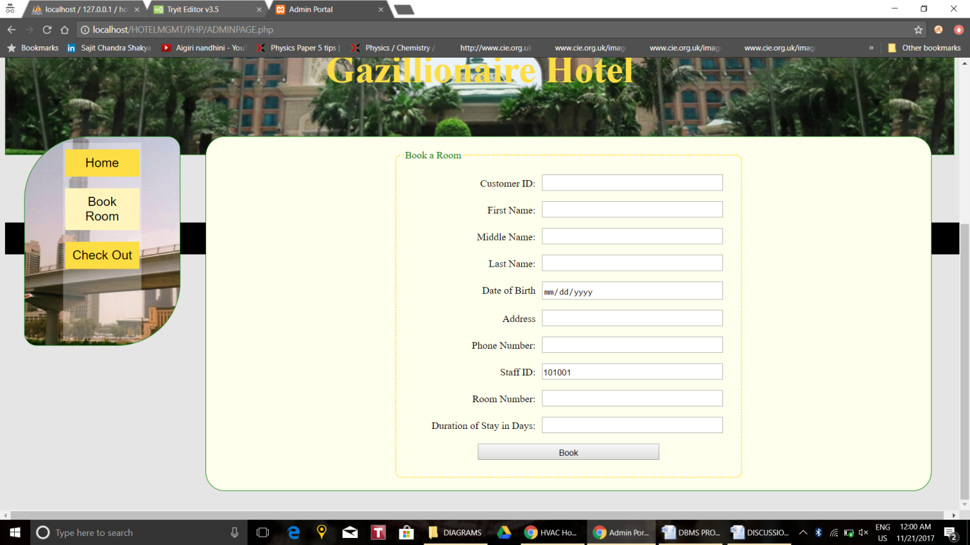

**Fig 5.11 Booking a Guest**

The admin, on arrival of the guest, will check them into their room by filling out the form shown in **Fig 5.11**. The staff member who performs this is recorded (notice the Staff ID field is filled in already with the logged in staff member's ID and is "readonly"). The underlying HTML is given in section **4.3.1** part **ii.** The information of the form is passed by "POST" method to the PHP as shown in section **4.3.2** part **vi-a**. This PHP form inserts the relevant fields into the **CUSTOMER** table by the query given in section **4.2.3** part **iv-a** query **i** and updates the chosen room in the **ROOM** table to reflect its occupancy and duration of stay by the query given in section **4.2.3** part **iv-a** query **ii.**

Booking a room which is already booked, or entering an invalid room number will cause the PHP page to redirect to an error report page shown in **Fig 5.12.**

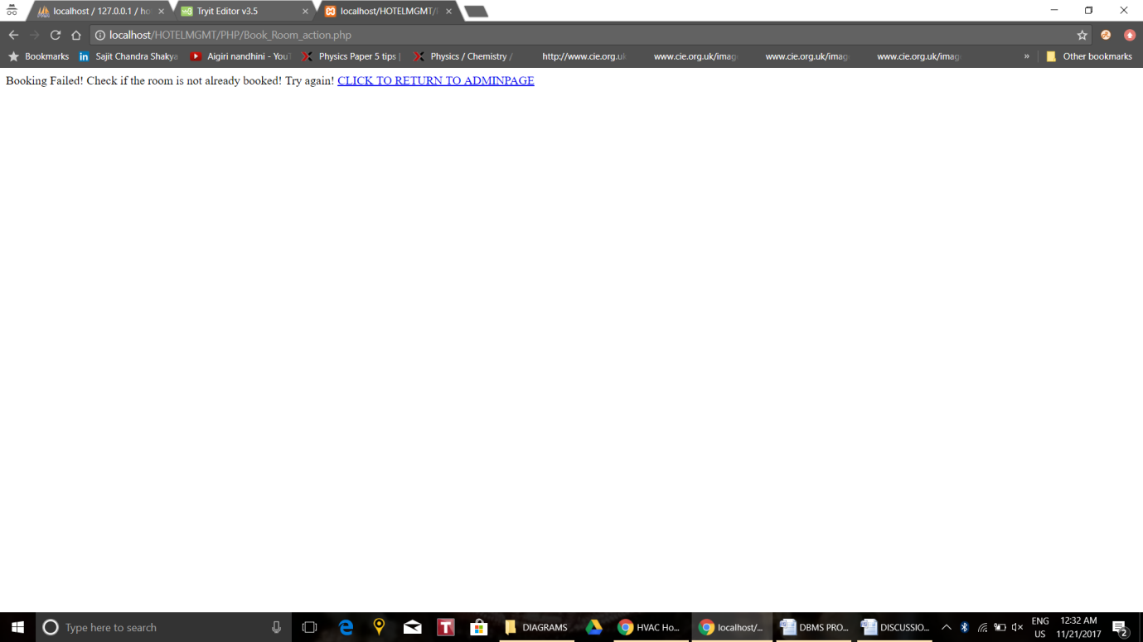

**Fig 5.12 Room Booking Failure**

* + 1. **Check-out Page:**

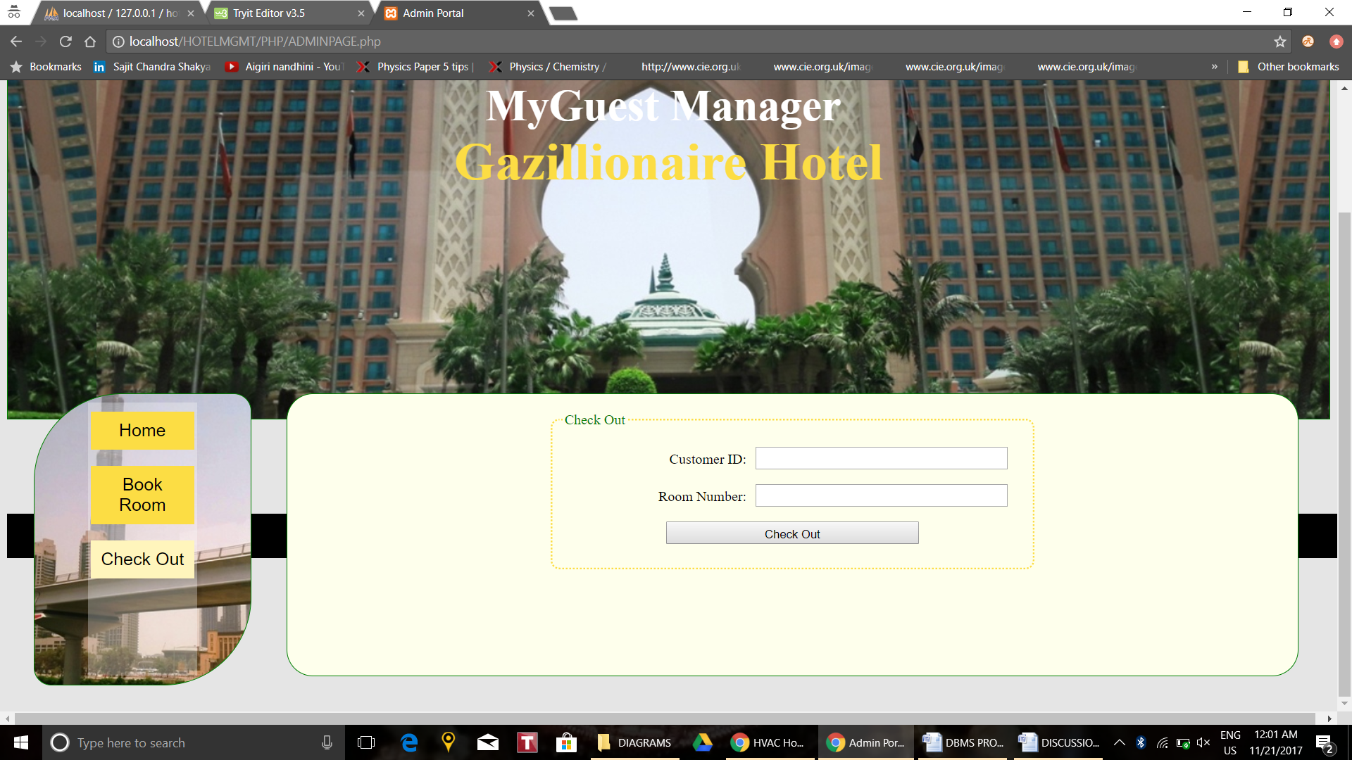

**Fig 5.13 Checking Out**

The admin, when the guest is to leave, will check-out the guest by filling out the form shown in **Fig 5.13**. The information of the form is passed by "POST" method to the PHP as shown in section **4.3.2** part **vi-b**. This PHP form deletes the customer's record from the **CUSTOMER** table by the query given in section **4.2.3** part **iv-b** query **i** and updates the guest's room in the **ROOM** table to reflect its vacancy and resets duration of stay to **null** by the query given in section **4.2.3** part **iv-b** query **ii.** The deletion from **CUSTOMER** is cascaded to delete the customer's food orders and amenity bookings from **ORDERED_BY** and **AVAILS** to prevent redundancy. This is achieved by using **ON DELETE CASCASE** in the table creation as shown in section **4.2.1** parts **v, vii, ix, xi, xiii.**

Incorrect entry of Customer_Id and Room Number combinations or entering an invalid room number will cause the PHP page to redirect to an error report page shown in **Fig 5.14.**

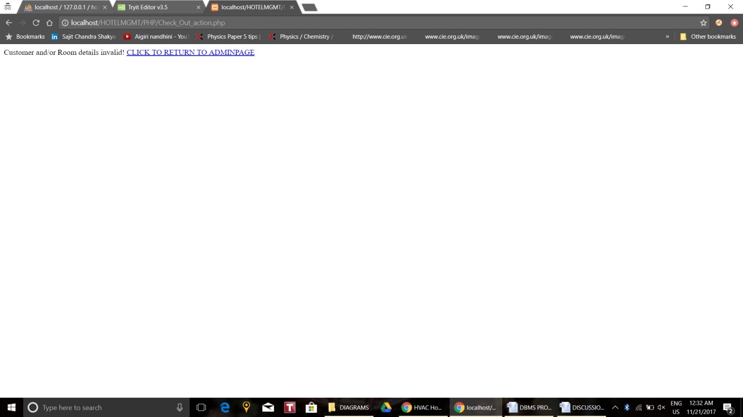

**Fig 5.14 Check Out Failures**

**Chapter 6**

**CONCLUSION AND FUTURE SCOPE**

**6.1 Conclusion**

A portal was successfully designed for the guests and front-desk staff members of a hotel. The portal provided the guests to order room service, book amenities and to view his/her bills with ease. The job of checking in the guests and to check them out was given to the front-desk staff.

This system can take over the existing methods followed in a hotel can turn out to be very efficient with many advantages, providing ease to the customers as well as the staff members.

**6.2 Future Scope**

The MyGuest Manager system can be implemented as a replacement to traditional 'human' reliant room service systems. This is especially useful in hotels on a budget which can make savings on having to hire too many room attendants or front desk staff. This system may be used in conjunction with a system that updates orders and pushes them to the kitchen. For example, once a guest orders food, this information can be relayed to the management system for the kitchen which can prompt the staff to prepare and send the food. Furthermore, more features such as summaries and staff management systems can be added to the basic functionality of the system to extend the benefits to not only the guests but also to the staff/managers working at the hotel.

**BIBLIOGRAPHY**

1. Elmasri, Ramez, and Shamkant B Navathe. *Fundamentals of Database Systems*. 7th ed., Pearson, 2017.
2. “HTML Element Reference.” *HTML Reference*, ww.w3schools.com/tags/default.asp.
3. “CSS Reference.” *CSS Reference*, www.w3schools.com/cssref/default.asp.
4. “PHP Tutorial.” *PHP 5 Tutorial*, www.w3schools.com/php/default.asp.